**UPGRADING AND UTILIZATION OF TIRE PYROLYTIC CHAR AS A POTENTIAL ADSORBENT FOR THE REMOVAL OF METHYLENE BLUE DYE**

By

T. B. N. Peiris

(SC/2016/9621)

A thesis submitted to the Department of Chemistry, Faculty of Science, University of Ruhuna, in Partial Fulfillment of the Requirements for the B.Sc. (Special) Degree in Chemistry.

Matara, Sri Lanka

August, 2021

**DECLARATION**

I certify that this thesis does not incorporate, without acknowledgement, any material previously submitted for a degree or a diploma in any university or institute to the best of my knowledge and does not contain any material previously published, written or communicated by another person except, where due credit is made in the text.

……………………………............ .……………………………...

Date Signature of the Student

T. B. N. Peiris

SC/2015/9271

……………………………............. …………………………………

Dr. J. S. Hewage Dr. A.S. Ranaweera

Supervisor, Co Supervisor,

Senior Lecturer Senior lecturer,

Department of Chemistry Department of chemistry

University of Ruhuna University of Ruhuna,

Matara, Matara

Sri Lanka. Sri Lanka.

**ABSTRACT**

The disposal of waste tires is one of the crucial environmental issues in the world and pyrolysis has identified as a sustainable solution to minimize the accumulation of waste tires on earth. The waste tire pyrolysis process produces three main products: pyrolytic oil, gas and, char. Pyrolytic oil and gas can be used in a variety of applications, including chemical feedstocks and high-energy fuels. Low-quality pyrolysis char has a low economic value and the disposal of solid char is problematic. Upgrading pyrolytic char to the form of carbon black might have various applications giving an economic value to the waste. In the current study, three different adsorbents: untreated, demineralized and activated tire pyrolytic char were prepared and evaluated their waste water-dye color removing capability. The pyrolytic char was demineralized by using HCl and NaOH. It activated by impregnating KOH onto tire pyrolytic char. All adsorbents were characterized by elemental analysis, thermogravimetric analysis (TGA), X-ray diffraction (XRD) and scanning electron microscopy(SEM) to determine the chemical, thermal and surface characteristics. Methylene blue (MB) was dissolved in water to simulate the colored waste water dye. The effect of process parameters such as adsorbent dosage, contact time, pH and temperature on the adsorption of methylene blue dye by tire pyrolytic char. demineralized tire char and activated tire char were investigated and compared with the values of commercially available carbon black (N330). Desorption studies were carried out with dye-adsorbed demineralized tire char and it was found that demineralized tire char has the potential to be reused more than six times. Langmuir isotherm model was the best fit for the experimental equilibrium results for demineralized tire char and activated tire char while the Frendlich isotherm was the best fit for the equilibrium data for tire pyrolytic char and commercial carbon black. Activated char has a greater adsorption capacity of 133.33 mg/g comparable to the values of demineralized char and commercial carbon black (N330) which have 46.51 mg/g and 7.10 mg/g respectively. Therefore, the maximum adsorption capacities of the adsorbents were in the order: activated tire char $>$ demineralized tire char $>$ commercial carbon black (N330) $>$ tire pyrolytic char.

Key words: Pyrolysis, Tire pyrolytic char, Demineralization, Activation, Adsorbent, Methylene blue, Desorption

**ACKNOWLEDGEMENT**

First and foremost, I would like to express my utmost gratitude to my supervisor Dr. Jeewantha S. Hewage and co supervisor Dr. Samantha Ranaweera of Department of Chemistry, Faculty of Science, University of Ruhuna whose guidance and dedicated involvement made this work a great success.

I also deliver my honest gratitude to Dr. G. B. C. Sanath, Head of the Department of Chemistry, Faculty of Science, University of Ruhuna for giving me this opportunity as a partial fulfillment of B.Sc. (Special) Degree in Chemistry.

Further, I express my gratefulness to all the academic staff members of Department of Chemistry, Faculty of Science, University of Ruhuna for their valuable support and guidance. All the non-academic staff members should also be thanked for their frequent support during my research work. Finally, I express my heartfelt gratefulness to my family members for encouraging me throughout this research work. I also thank my fellow classmates for their moral support during this period.

Finally, the grant “AHEAD RIC R2 No 18, Department of Chemistry, University of Ruhuna” is greatly appreciated for the financial support given throughout this research.

**TABLE OF CONTENT**

**CHAPTER 01**

1 Introduction 2

1.1 Waste tires and their disposal 2

1.2 Tire pyrolysis 3

1.3 Tire Pyrolysis char 3

1.3.1 Tire pyrolytic char general composition. 4

1.4 Potential applications of pyrolysis char 5

1.5 Purification of pyrolytic tire char 6

1.5.1 Demineralization 6

1.5.1.1 Factors affecting the properties of pyrolytic tire char during demineralization 6

1.5.1.1.1 Surface area 7

1.5.1.1.2 Particle size 7

1.5.1.1.3 Temperature 7

1.5.1.1.4 Contact time and leaching rate 8

1.5.1.1.5 Solvent and pH 8

1.5.1.1.5.1 Water 9

1.5.1.1.5.2 Acids 9

1.5.1.1.5.3 Bases 10

1.5.2 Activation of waste tire pyrolysis char 11

1.5.2.1 Physical activation 12

1.5.2.2 Chemical activation 12

1.6 Adsorption properties of tire pyrolysis char 14

1.7 Dye bearing wastewater treatment 16

1.7.1 Current treatment technologies for dye removal 17

1.7.1.1 Physical methods 18

1.7.1.2 Chemical treatment 18

1.7.1.3 Biological methods 19

1.7.2 Adsorption as an effective wastewater treatment process 19

1.7.2.1 The process of adsorption 20

1.7.3 Removal of Methylene blue dye (MB) by adsorption 21

Methylene blue dye 22

1.8 Adsorption isotherms 22

1.9 Desorption/Regeneration studies 24

1.10 Research problem 25

**CHAPTER 02**

2 Materials and methods 26

2.1 Apparatus 26

2.2 Batch adsorption experiments 26

2.3 Preparation of reagents 27

2.3.1 Preparation of methylene blue solutions 28

2.3.2 Preparation of NaOH and HCl solutions. 28

2.3.2.1 Preparation of 0.1 M HCl solution 28

2.3.2.2 Preparation of 0.1 M NaOH solution 28

2.3.2.3 Preparation of 1 M HCl solution 28

2.3.2.4 Preparation of 2 M HCl solution 28

2.3.2.5 Preparation of 2 M NaOH solution 29

2.4 Pretreatment of pyrolysis tire char Sieving process 29

2.5 Adsorbent development 29

2.5.1 Demineralized tire char preparation 29

2.5.2 Activation of demineralized tire pyrolytic char 31

2.6 Char characterization 32

2.7 Determination of the effect of adsorbent dosage on adsorption of methylene blue by different char types 32

2.7.1 Tire pyrolysis char 32

2.7.2 Demineralized tire char 33

2.7.3 Activated tire char 33

2.7.4 Commercial carbon black 33

2.8 Determination of the effect of contact time on adsorption of methylene blue dye on different char types 34

2.8.1 Tire pyrolysis char 34

2.8.2 Demineralized tire char 34

2.8.3 Activated tire char 35

2.8.4 Commercial carbon black 35

2.9 Determination of the effect of pH on adsorption of methylene blue by different char types. 36

2.9.1 Tire pyrolysis char 36

2.9.2 Demineralized tire char 36

2.9.3 Activated tire char 36

2.9.4 Commercial carbon black 37

2.1 Determination of the effect of temperature on adsorption of methylene blue by different char types 37

2.1.1 Tire pyrolysis char 37

2.1.2 Demineralized tire char 38

2.1.3 Activated tire char 38

2.1.4 Commercial carbon black 38

2.2 Desorption studies 39

**CHAPTER 03**

3 Results and discussion 40

3.1 Char characterization 40

3.1.1 Ultimate analysis of prepared adsorbents. 40

3.1.2 Proximate analysis 41

3.1.2.1 Thermogravimetric Analysis 41

3.1.3 XRD Analysis 46

3.1.4 Surface morphology 48

3.2 Effect of adsorbent dosage 51

3.3 Effect of contact time 58

3.4 Effect of pH 64

3.5 Effect of temperature 69

3.6 Desorption studies-repeatability of the adsorbent 76

3.7 Adsorption isotherm modelling 79

3.7.1 Langmuir isotherm model 79

3.7.2 Freundlich isotherm model 80

3.7.3 The Langmuir and Freundlich isotherm constants and determination coefficients ( $R2)$ for methylene blue adsorption on adsorbents. 91

**CHAPTER 04**

4 Conclusions, suggestions, and future perspectives 94

References………………………………………………………………………………..96

**LIST OF TABLES**

**Table 1.1**. CHNSO composition of tire pyrolytic char16 17

**Table 1.2**. Metal content of tire pyrolytic char16 17

**Table 3.1**. CHN analysis of adsorbents 53

**Table 3.2**. Proximate analysis-TGA analysis of tire pyrolytic char, demineralized tire char and activated tire char 58

**Table 3.3**. Average data for the determination of effect of adsorbent dosage on removal of methylene blue dye at various adsorbent dosages of tire pyrolytic char. Experimental conditions-Agitating speed: 120rpm, Contact time: 15min, Temperature: 29 $℃$ 64

**Table 3.4**. Average data for the determination of effect of adsorbent dosage on removal of methylene blue dye at various adsorbent dosages of demineralized tire char. Experimental Conditions-Agitating speed: 120rpm, Contact time: 15min, Temperature: 29 $℃$ 65

**Table 3.5.** Average data for the determination of effect of adsorbent dosage on removal of methylene blue dye at various adsorbent dosages of activated tire char. Experimental conditions-Agitating speed: 120rpm, Contact time: 15min, Temperature: 29 $℃$ 66

**Table 3.6**. Average data for the determination of effect of adsorbent dosage on removal of methylene blue dye at various adsorbent dosages of commercial carbon black. Experimental conditions-Agitating speed: 120rpm, Contact time: 15min, Temperature: 29 $℃$ 68

**Table 3.7**. Summary of adsorbent dosages at maximum dosage of adsorbents 71

**Table 3.8**. Average data for the effect of contact time on adsorption of methylene blue dye on tire pyrolytic char. Experimental conditions: Agitating speed: 120rpm, Adsorbent dosage: 0.4g, Temperature: 29 $℃$ 72

**Table 3.9**. Average data for the effect of contact time on adsorption of methylene blue dye on demineralized tire char. Experimental conditions: Agitating speed: 120rpm, Adsorbent dosage: 0.2 g, Temperature: 29 $℃$ 73

**Table 3.10**. Average data for the effect of contact time on adsorption of methylene blue dye on activated tire char. (Experimental conditions: Agitating speed: 120rpm, Adsorbent dosage: 0.1g, Temperature: 29 $℃$.) 74

**Table 3.11**. Average data for the effect of contact time on adsorption of methylene blue dye on commercial carbon black. Experimental conditions: Agitating speed: 120rpm, Adsorbent dosage: 0.4 g, Temperature: 29 $℃$. 75

**Table 3.12**. Average data for the effect of pH on adsorption of methylene blue dye tire pyrolytic char. Experimental conditions: Agitating speed: 120rpm, Adsorbent dosage: 0.4 g, Contact time: 20min, Temperature: $29℃$ 77

**Table 3.13**. Average data for the effect of pH on adsorption of methylene blue dye on demineralized tire char. Experimental conditions: Agitating speed: 120rpm, Adsorbent dosage: 0.2 g, Contact time: 20min, Temperature: $29℃$. 78

**Table 3.14**. Average data for the effect of pH on adsorption of methylene blue dye on activated tire char. Experimental conditions: Agitating speed: 120rpm, Adsorbent dosage: 0.1 g, Contact time: 20 min, Temperature: $29℃$ 78

**Table 3.15**. Average data for the effect of pH on adsorption of methylene blue dye on commercial carbon black. Experimental conditions: Agitating speed: 120rpm, Adsorbent dosage: 0.4 g, Contact time: 20 min, Temperature: $29℃$ 79

**Table 3.16**. Average data for the effect of temperature on adsorption of methylene blue dye on pyrolysis tire char. Experimental conditions: Agitating speed: 120rpm, Adsorbent dosage: 0.4g, Contact time: 20 min. 82

**Table 3.17**. Average data for the effect of temperature on adsorption of methylene blue dye on demineralized tire char. Experimental conditions: Agitating speed: 120 rpm, Adsorbent dosage: 0.2 g, Contact time: 20 min 83

**Table 3.18**. Average data for the effect of temperature on adsorption of methylene blue dye on activated tire char. Experimental conditions: Agitating speed: 120 rpm, Adsorbent dosage: 0.1 g, Contact time: 20 min 84

**Table 3.19**. Average data for the effect of temperature on adsorption of methylene blue dye on commercial carbon black. Experimental conditions: Agitating speed: 120 rpm, Adsorbent dosage: 0.4 g, Contact time: 20 min 85

**Table 3.20**. Comparison of the %dye removal before optimization and after optimization 88

**Table 3.21**. Average data for the percentage of methylene blue dye desorbed by demineralized tire char 90

**Table 3.22.** Average data for the adsorption isotherms of tire pyrolytic char 94

**Table 3.23**. Average data for the adsorption isotherms of demineralized tire char 97

**Table 3.24**. Average data for the adsorption isotherms of activated tire char 99

**Table 3.25**. Average data for the adsorption isotherms of commercial carbon black 101

**Table 3.26.** The Langmuir and Freundlich isotherm constants for methylene blue adsorption on tire pyrolytic char 104

**Table 3.27**. Adsorbent capacities of different adsorbents for the removal of methylene blue 105

**LIST OF FIGURES**

**Figure 1.1**. Schematic diagram of demineralization mechanism14 14

**Figure 1.2**. Macropores,mesopores and micropores 19

**Figure 1.3**. The sources of synthetic dyes in aquatic environment69 24

**Figure 1.4**. Physisorption 28

**Figure 1.5**. Chemisorption 28

**Figure 1.6.** Structure of the methylene blue chloride salt 29

**Figure 1.7**. The possible adsorption mechanisms 30

**Figure 1.8**. The adsorption mechanism reveals by the Langmuir isotherm model 31

**Figure 2.1**. First wash with 2M HCl 38

**Figure 2.2**. Second wash with 2M HCl 38

**Figure 2.3**. Third wash with 2M NaOH 39

**Figure 3.1**. TGA spectrum of tire pyrolytic char 50

**Figure 3.2**. TGA spectrum of demineralized tire char 51

**Figure 3.3**. TGA spectrum of activated tire char 52

**Figure 3.4**. TGA spectrum of commercial carbon black (N330) 53

**Figure 3.5**. X-ray diffraction patterns of tire pyrolytic char 55

**Figure 3.6**. X-ray diffraction patterns of demineralized tire char 56

**Figure 3.7**. X-ray diffraction patterns of activated tire char 57

**Figure 3.8**. SEM images of tire pyrolytic char 58

**Figure 3.9**. SEM images of demineralized tire char 59

**Figure 3.10**. SEM images of activated tire char 59

**Figure 3.11**. Effect of adsorbent dosage on removal of methylene blue by tire pyrolytic char (a), demineralized tire char(b), activated tire char(c) and, commercial carbon black(d) (Agitating speed: 120 rpm, Contact time: 15 min, Temperature:29 $℃$) 66

**Figure 3.12**. Effect of contact time on removal of methylene blue by tire pyrolysis char, demineralized char, activated char and commercial carbon black (Agitating speed: 120rpm, Adsorbent dosage: 0.4g ,0.2 g ,0.1 g and 0.4 g per 50 mL of methylene blue solution for tire pyrolytic char, demineralized char, activated char and commercial carbon black respectively, Temperature: 29 $℃$) 72

**Figure 3.13.** Effect of pH on removal of methylene blue by tire pyrolytic char, demineralized tire char, activated tire char, and commercial carbon black (Agitating speed: 120rpm, Adsorbent dosage: 0.4 g, 0.2 g, 0.1 g, and 0.4 g per 50 mL of methylene blue solution of tire pyrolytic char, demineralized char, activated char and commercial carbon black respectively, Contact time: 20 min, Temperature: 29 $℃)$ 76

**Figure 3.14**. Effect of temperature on removal of methylene blue by tire pyrolysis char, demineralized char, activated tire char and commercial carbon black (Agitating speed: 120rpm, Adsorbent dosage: 0.4 g ,0.2 g, 0.1 g , and 0.4 g per 50 ml of methylene blue solution for tire pyrolysis char, demineralized char, activated char and commercial carbon black respectively. Contact time: 20 min) 81

**Figure 3.15**. Reusability of demineralized char on dye removal (Agitating speed: 120rpm, Adsorbent dosage (Demineralized tire char):0.2 g per 50 mL of methylene blue solution, Contact time: 20 min, Initial methylene blue concentration: 50 ppm $,$ Temperature: 40 $℃$, pH -6) 85

**Figure 3.16**. Equilibrium methylene blue solutions at each cycle (from left to right; cycle 01 to cycle 06) 85

**Figure 3.17.** The Langmuir isotherm model for the adsorption of methylene blue on tire pyrolytic char 90

**Figure 3.18**. Freundlich isotherm model for the adsorption of methylene blue on tire pyrolysis char 90

**Figure 3.19**. Langmuir adsorption model for the removal of methylene blue dye on demineralized tire char 92

**Figure 3.20**. Freundlich isotherm model for the removal of methylene blue dye on demineralized tire char 92

**Figure 3.21**. Langmuir adsorption model for the removal of methylene blue on activated tire char. 94

**Figure 3.22**. Freundlich adsorption model for the removal of methylene blue on activated tire char 94

**Figure 3.23**. Langmuir adsorption model for the removal of methylene blue on commercial carbon black. 96

**Figure 3.24**. Freundlich adsorption model for the removal of methylene blue on commercial carbon black 97

**CHAPTER 01**

# Introduction

## Waste tires and their disposal

Solid waste generation has enhanced extensively around the world in recent decades and there are no significant signs of slowing down. Waste tires occupy a significant place among other solid wastes which cause many environmental issues.

Waste tire disposal is one of the major and crucial global problem1. Tire production is estimated to be over 1.4 billion units per year, equating to 17 million tons of waste tires per year2. An estimated 1000 million tires arrive at the end of their useful lives every year and more than 5000 million are assumed to be discarded by the year 20303. As the used tires are industrial waste, they should be reused according to sustainable development principals3.

Waste tires can be utilized as additives in road pavements, rubber roofs, playground surfaces, drainage systems, energy generation, and etc4. However, they may cause additional pollution if continued in an uncontrolled way because these applications are not reach environmental satisfaction2.

The most popular disposal method of waste tires is to stockpile in the landfill. However, it has been considered as a non-environmental friendly and uneconomical disposal method5. Rubber molecules are less able to biodegrade and neither melt nor dissolve because they are chemically cross-linked to each other6,7. Tire stockpiling leads to fire hazards that may cause pollution of air where they can emit noxious gases containing carcinogens and uncontrollable burning. Also, they provide breeding grounds for mosquitos and rodents causing various harmful diseases affecting human health5–7.

Among the various tire disposal techniques, recycling has been deemed the most successful. However, due to the high complexity of the structure and the diverse composition of waste tires, recycling is a huge challenge.

## Tire pyrolysis

Some available processes deal with prevailing challenges in waste tire accumulation are incineration, reclaiming, retreating, grinding, biodegradation, gasification, pyrolysis, and hydrothermal liquefaction8,9. Among these different methods, Pyrolysis has been considered a viable technology for recycling waste tires10.

Pyrolysis involves the thermal decomposition of organic compounds in an inert oxygen-free atmosphere at 400 $℃$-700 $℃$ under low pressure and it has been identified as an environmentally friendly and effective waste tire recycling method2,11. It is an alternative process that adds a significant value for the waste tires. During the pyrolysis process, waste tires decompose thermally into pyrolysis gas(low molecular weight non-condensable pyrolysis products), pyrolysis oil(high molecular weight condensable compounds), and pyrolysis char as a solid11,12. Based on the pyrolysis conditions, tire char represents from 30%-40% of the initial weight2,7. Apart from char, 38-55% wt. % oil and 10-30% wt. % gas is recovered by a typical process of pyrolysis.

Although oil and gas formed can be utilized in many applications such as chemical feedstock or fuels with high calorific value, low-quality pyrolysis char has less economic value13 and it should be improved to produce value-added products. Therefore, to achieve a balanced economy and environment, tire pyrolysis char which is generated from the pyrolysis process should be utilized in many smart ways.

## Tire Pyrolysis char

Pyrolytic char has a porous, heterogeneous structure with a low surface area, primarily composed of carbon black added during the tire manufacturing process. Since volatile products produced during pyrolysis appear to get absorbed on the surface of the char as carbonaceous materials, the char is much coarser than the carbon black applied to the tire during manufacturing.

Pyrolytic char contains a variety of undesirable components, including about 25 wt% of ash, results from tire additives, which minimize its commercial value. To be used in more challenging applications, tire-derived char must be improved by eliminating contaminants such as tire-derived oil, sulfur, metals, and silicon from the carbon structure14. The high ash, sulfur, and zinc contents of raw char, prevents it from being used as carbon black in conservative tire manufacturing.

### Tire pyrolytic char general composition.

In general, tire char is made up of carbon and inorganics (e.g: Zn, Ca, and Si containing compounds)which have added in the tire manufacturing process with varying compositions based on the pyrolysis circumstances and tire composition15.

Typically, the carbon content of the tire pyrolytic char was proportinately high with around 82% with minor amount of hydrogen,nitrogen and sulphur and, an oxygen conent around 11 wt%16 as given in the Table 1.1. According to the Table 1.2 of the metal content of pyrolytic char, the percentage of Zn is very higher compared to other metals found in tire pyrolytic char.

**Table 1.1**. CHNSO composition of tire pyrolytic char16

|  |  |  |  |  |
| --- | --- | --- | --- | --- |
| C(%) | H(%) | N(%) | S(%) | O(%) |
| 81.9 | 1.39 | 2.4 | 3.16 | 11.15 |

**Table 1.2**. Metal content of tire pyrolytic char16

|  |  |  |  |  |  |  |  |  |
| --- | --- | --- | --- | --- | --- | --- | --- | --- |
| Metal | Al | Ba | Ca | Co | Cr | Cu | Fe | K |
| Tire char  (ppm) | 1,380 | 70 | 3,000 | 130 | 100 | 340 | 3,820 | 800 |
| Metal | Mg | Mn | Na | Ni | Pb | Ti | V | Zn |
| Tire char  (ppm) | 740 | 60 | 550 | 60 | 110 | 130 | 100 | 20,260 |

## Potential applications of pyrolysis char

The char produced from the pyrolysis process can be utilized to produce fuel for energy17, syngas production, or converted to value-added carbonaceous products such as carbon black or activated carbon11. In syngas production, tire char is utilized as a catalyst and a source of syngas in pyrolysis-reforming of biomass. Metals in tire char catalyze the breakdown of tar. Simultaneous reforming and gasification of pyrolysis gases and char could help increase gas yield while lowering tar levels in the final syngas18. A more promising application with a highly added value is the using of char as carbon fillers (usually referred to as carbon black) for strengthening rubber or increasing the performance of bitumen. Carbon fillers are in high demand in a variety of industries and continue to rise19. Therefore recovering carbon black is the promising remedy for the waste generated from the tire pyrolysis process. This treatment gives it several valuable qualities, making recovered carbon black as a high-value added product that may be used as a filler in the rubber sector such as in tire manufacturing, paints and coatings, ink production, and a variety of other industries20.

Moreover, due to the high surface area and rich surface functional groups, the char might be employed directly or after treatment as adsorbents for pollutant removal. However, the high amount of minerals in the char would make it difficult to use pyrolysis tire char as a carbon black substitute21. The inorganic species in the feedstock mainly end up in the solid fraction, polluting the char and limiting its applications. For example, when using char as an activated carbon sorbent precursor, minerals may influence the porosity of the char by blocking the activating agent's access to the internal pores. Therefore pyrolytic tire char must be purified for more potential applications either by removing minerals or it can be modified into activated carbon by adding activating agents.

## Purification of pyrolytic tire char

### Demineralization

Demineralization by leaching is the most widely used method for completely removing or reducing the amount of metals and other impurities found in pyrolytic tire char. It is a form of liquid-solid extraction in which a soluble fraction (leachate or solute) is extracted partially or completely from an insoluble or permeable solid phase with the aid of a liquid lixiviant22. During the process of demineralization, first, the solvent invades the solid and diffuses through the pores, dissolving the leachate until there is intimate contact. Finally, the solute diffuses to the surface, where it is passed to the bulk solution, resulting in the isolation of the solid's components.

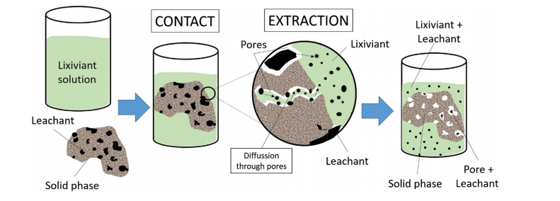

**Figure 1.1**. Schematic diagram of demineralization mechanism14

#### Factors affecting the properties of pyrolytic tire char during demineralization

For the process of demineralization, some major process parameters must be determined. These criteria are difficult to determine since there may be many competing variables23.

##### Surface area

The particle size and shape define the feedstock's surface area. Demineralization would be encouraged if there was more surface area and better access to pollutants due to high porosity. During pyrolysis, the release of volatile organic components increases the porosity network and surface area of char, making it more available to solvents.

##### Particle size

Smaller particle sizes are preferred because they increase the contact area between the solid and the liquid, allowing for faster mass transfer. Furthermore, the distance that the solute must travel through the solid's interior is shorter, which aids leaching. Some solid particles can be crushed and ground to make the soluble component more available to the solvent, speeding up the leaching process24. However, the cost of processing fine particles is unfeasible for waste tires because it may necessitate grinding under cryogenic conditions25.

##### Temperature

Due to the greater solubility of the solute in the solution, it is preferable to use high leaching temperature, resulting in higher solute concentrations in the liquid product. Mass transfer is also aided by the lixiviant's lower viscosity at high temperatures. The temperature to be used will be determined by the substance being processed26.

However, higher temperatures come with higher energy requirements and production costs, which should be considered when deciding on the best value14.

##### Contact time and leaching rate

Leachability is a time-dependent property that usually changes over time. The reaction kinetics determine the length of time. Leaching is usually very quick at first, but after a while, the rate of leaching slows down. The high initial rate of dissolution is due to two factors: the solvent concentration is normally at its highest, and the maximum potential surface of soluble mineral is exposed. The rate of dissolution slows as the contact surface decreases because most minerals have already been dissolved and the solvent intensity depletes27.

Leaching would be favored by increasing the surface area per unit volume of solid to be removed, regardless of the contact form. The importance of stirring the solvent is that it increases material transfer from the surface of the particles to the mass of the solution14.

##### Solvent and pH

The nature of the sample and the chemicals targeted during the demineralization process can influence the solvent and pH used, so the solvent should be thoroughly investigated along with the chemistry of the process14. It is extremely difficult to choose the best solvent for a demineralization process since there are so many parameters to be considered. The solvent chosen should have the best combination of desirable characteristics such as solubility, chemical reactivity, and viscosity14.

The solubility is to ensure that no carrier (inert solid phase) dissolves in the demineralizing agent, both the solvent and the carrier must be largely insoluble in each other. Underthechemical reactivity, The solvent must not react with the solute in an undesirable way and must be chemically stable under process conditions, such as to prevent oxidation. A low pH value indicates that there are more H+ ions available to react with metals, and high redox potentials are required to remove soluble metals from solids. Since high viscosity values minimize mass transfer and heat transfer rates, low and medium viscosity solvents are preferred.Corrosiveness, flammability, toxicity, and recoverability are only a few of the additional solvent properties that must be considered because they impact the overall cost of the process14.

Solvents can be divided into three classes based on their pH: They are water, acids and bases.

###### Water

Water is considered the most preferred solvent due to its low cost and less environmental impact. Water leaching is used to remove water-soluble inorganic elements including calcium, potassium, magnesium, and sodium and other inorganic salts dissolve in water as well28.

Some chemical reactions are taking place during water demineralization

CaO(s) + O(l) Ca(aq)

MgO(s) +O(l) Mg(aq)

Na and K also can form soluble hydroxides14.

Na(s) + O(l) NaOH(aq) + (g)

K(s) + O(l) KOH(aq) + (g)

###### Acids

Acid solutions are needed to eliminate non-water-soluble components. Metal ion solubilization is commonly favored at low pH levels. Since most metals and metal ions can only react with acids, acids play a major role in the demineralization process29. Oxidation- reduction reactions are the most common mechanism for these reactions. The elements' reactivity is determined by their ability to act as reducing agents. $H_{2}{SO}_{4}$ and HCl is the two most common acids used in the demineralization of pyrolytic char30. Both acids are extremely strong, inexpensive, and readily available. The H+ ions are replaced with metal cations during their demineralization reactions31

.

###### Bases

The most widely used alkali solvents for the demineralization process are NaOH, ${Ca(OH)}_{2}$, KOH, ${Na}_{2}{CO}_{3}$ and, ${{NH}_{4}}^{+}$. Among these bases, sodium hydroxide has the strongest leaching capacity. After dissolving in water, sodium carbonate becomes a weak base. As compared to acids, bases are more selective in dissolving some elements. Base has the ability to dissolve silica (at high temperatures),alumina, and eliminate various sources of sulphur32. Alkaline demineralization has faster kinetics and a simpler impurity removal mechanism than acid demineralization. However, because of the higher cost of caustic soda, alkaline demineralization is less competitive than acid demineralization. As a result, despite their ability to remove metals, alkaline solvents are often used in combination with acids21.

When demineralization is carried out as a post-treatment on tire-derived pyrolytic char, the application of strong acids was found to be effective in the elimination of huge amounts of inorganic minerals such as Zn, Ca, K, Fe, and some organic materials33. In certain cases, alkali solvents are much more effective than acids at removing metals and metal oxides34. The best solvent for extracting Si compounds appears to be NaOH. Using various acids or acids and alkali sequentially removes the minerals in greater quantities. The acid or acid/alkali demineralization of char raises its surface area values34. Demineralization increased the importance of chars as an energy source by increasing their fixed carbon content and calorific values.

To produce new porosity and/or improve the one already present in the sample, the char must be activated either physically or chemically. The demineralization stage can be done before6 or after35 the activation process. A demineralization step is desired before activation to remove the maximum amount of contaminant metals. Removing minerals from the surface before activating will help the porosity grow more quickly since the activating agent would have easier access through the newly formed pores.

However, the removal of certain elements such as Ca and Zn, which may have a catalytic effect during activation, may reduce the reactivity of activated carbon17.

### Activation of waste tire pyrolysis char

Activated carbon is a versatile adsorbent with a large specific surface area, a porous structure, high adsorption power, and high surface reactivity. Commercial activated carbon is often used to extract contaminants from water, but it can be costly, so the quest for low-cost, high-performance materials has piqued interest.

The high specific surface to capture and entrap the target molecules is due to the large pore size distribution and well-developed pore structure. Micropores (less than 2 nm), mesopores (between 2 and 50 nm), and macropores (greater than 50 nm) are the three forms of pores(Figure 1.2). Microporous activated carbon is used to adsorb gases and vapors, while mesoporous activated carbon is used to adsorb larger molecules including dyes and organic contaminants36. Since most gas molecules have diameters of less than 1.0 nm, a large number of micropores is needed for gas adsorption. Water pollutants have a larger molecular size, a large number of mesopores is needed for liquid adsorption. As a result, pore size distribution and the size of adsorbate molecules have a major impact on adsorption capability36.

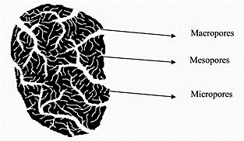

**Figure 1.2**. Macropores, mesopores and micropores

The quality of the pyrolytic tire char, or its ability to be used in relatively high-value commercial applications, is critical to the economic success of the tire pyrolysis process. Because of the presence of significant carbonaceous deposits, high ash content, and large particle size, its potential usage as a substitute for commercial carbon black is limited to low-quality applications. Activating pyrolytic char to produce high-quality activated carbon with a large surface area could be a cost-effective solution.

There are mainly two kinds of activation methods. They are,

* + - * Physical activation
      * Chemical activation

#### Physical activation

The physical method consists of two steps, the first of which is the carbonization (or devolatilization) process, which is carried out in an inert atmosphere in the presence of $N_{2}$ or Ar for a certain period at a temperature between 400 and 700 °C. The volatile compounds in tire rubber will be released as gaseous compounds in this process, and the tire rubber will be converted to char at the end. The second stage is the activation step, in which an activating agent such as C $O_{2}$ or steam is used to increase the porosity and specific surface area of the char at a temperature between 700 and 900 °C for some time, producing activated carbon37,38. This method, unlike chemical activation, does not require chemical mixing; it is safer for the environment, but it needs a high operating temperature and sometimes results in low product yield36.

The modified physical method used by Betancur et al. to produce activated carbon with a lower specific surface area by skipping the carbonization stage is an exception to the conventional physical method39.

#### Chemical activation

The chemical method is a one-step process that involves impregnating granulated tire rubber with a chemical activating agent such as KOH, stirring for about 5 hours, and then drying in an oven for 24 hours. The impregnated granules are then kept in an inert environment for some time, generally in a reactor at a temperature between 500 and 700 °C. After that, the substance is acid-washed to maximize its porosity and specific surface area39–45. Chemical activation has two significant advantages over physical activation. The first is that there is less energy consumption because the activating agent does not need to be heated, and the second is that tire pyrolysis and activated carbon processing can be done in one step46. As well as chemical activation is preferable to physical activation because it yields more carbon, which has more micro-and mesopores, and has a higher specific surface area and adsorption capability36.

Dehydrogenation properties of the chemical agents used in chemical activation prevent tar formation and excessive volatile production, resulting in high carbon yields47. Depending on the raw materials and activating agents used, it typically needs a lower activation temperature (500 to 700 °C) and a shorter activation period (30 minutes to 3 hours)48. The pore walls appear to collapse at high temperatures and with prolonged activation due to sintering and realignment of the carbon structure, reducing the pore characteristics and unique surface required for efficient adsorbent-adsorbate interactions.

Several parameters can be influenced by the process of chemical activation49.

* Solvent during impregnation
* The ratio of chemical agent(KOH) to the precursor(tire pyrolysis char)
* Pyrolysis temperature
* Holding time
* The pore structure of the activated carbons

The chemical agent-to-precursor ratio must be carefully chosen to produce activated carbon with good yield, specific surface, and adsorption properties. Activating agents oxidize a weak part of the carbon matrix to create pores. Because of the collapse of the pore structure, a high agent to precursor ratio often results in a small specific surface, but a high ratio that produces a high specific surface could result from high molecular weight precursor content, which would minimize the loss.

Activating agents commonly include alkali and alkaline earth metals, as well as certain acids.

* Potassium hydroxide (KOH)50–52
* Phosphoric acid ($H_{3}$ P)53–55
* Potassium carbonate56–58
* Zinc chloride (ZnC)59,60
* Sodium hydroxide(NaOH)61

To make activated carbons with a high specific surface and well-developed porosity, hydroxides like KOH and NaOH have been commonly used. However, since KOH is harmful to humans and aquatic creatures, its use as a chemical agent should be carefully regarded in terms of environmental sustainability36.

KOH activation results in activated carbon with a higher specific surface area and good pore growth.

During carbonization, KOH acts as a dehydrating agent, removing any water from the precursor, which would otherwise result in the formation of tar, which could clog the pores62. The carbonization process is defined as follows:

Dried precursor → Char + Tar + Gasses

During the process of activation, the following reactions take place63.

C(s) + 2KOH(aq) 2K(s) + (g)+ C(g)

C(s) + 2KOH(aq) 2K(s) + O(l) + CO(g)

C(g)+ 2KOH(aq) (aq) + O(l)

Mesopores and micropores are developed as a result of the potassium intercalation into the carbon network during the process of activation. There is also the possibility of secondary reactions, such as the reaction mentioned below.

$H_{2}$ O(l) + C(s) + 2KOH(aq) (aq) + (g)

## Adsorption properties of tire pyrolysis char

Adsorption is one of the most cost-effective and efficient wastewater treatment technologies, and activated carbon has long been one of the most widely used adsorbents for adsorption processes. Many studies have shown that pyrolysis char can be utilized effectively as a precursor of adsorbent and they have shown that activating tire char can produce a substance with similar properties to commercially available activated carbon, such as high surface area and porosity. As a result, this would be a sound solution for both the wastewater treatment and waste tire disposal problem. Many countries and environmental protection agencies are constantly limiting the use of chemicals and tightening discharge restrictions to minimize the serious problems caused by water contamination. Wastewaters containing toxic materials like dyes, organic pollutants, and metal ions must be treated carefully before being discharged.

Millions of people in different countries of the world suffering from a lack of fresh and clean water. Rapid industrialization, unplanned urbanization, and population expansion have greatly influenced severe water pollution. The discharge of untreated toxic industrial wastes and dumping of effluents from industries can be considered as major sources of natural water pollution64. Organic dyes can be considered as one of the most hazardous pollutants in natural water bodies. Dyes have largely influenced human life in many fields. Today, around 100,000 synthetic dyes are utilized commercially and over 700,000 tons of dyes are produced every year65. These synthetic dyes are greatly applied in textile, paper, paint, food, plastics, printing, cosmetic and pharmaceutical industries65,66. Many such industries discharge effluents containing the residues of dyes. During the process of dying, it is estimated that over 10-15 $\%$ of the dyes are removed in the effluents67. Textile industries alone consume dyes approximately over ${10}^{7}$ kg/year as total and it is estimated that 90% of this total ends up on fabrics68.

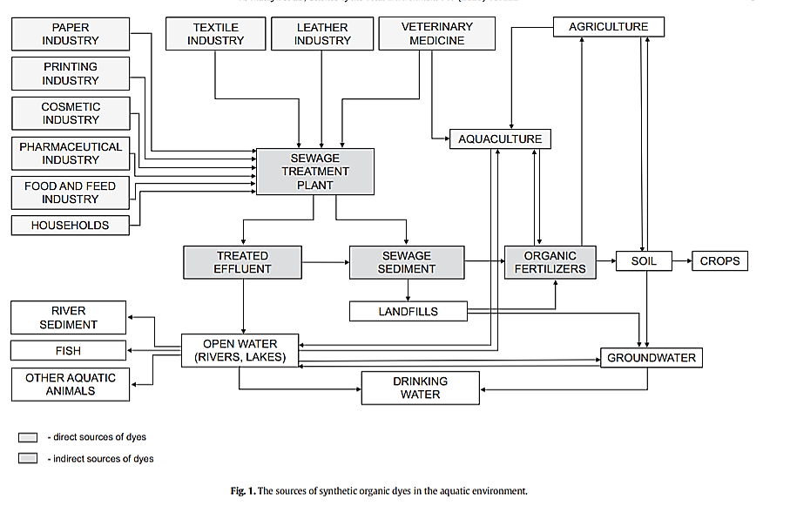

**Figure 1.3**. The sources of synthetic dyes in aquatic environment69

The presence of dyes even at very low concentrations in water resources is highly visible and decreases the light penetration and this may subsequently threats the photosynthesis of aqueous flora66and damages the aesthetic nature of water bodies.

Moreover, the degradation products of dyes are mutagenic and carcinogenic. Most of the synthetic dyes cause skin irritation which provokes mutations and cancer in extreme cases, allergy, dermatitis, dysfunction of kidney, liver, brain, reproductive system, and central nervous system66,67.

## Dye bearing wastewater treatment

Dyes discharged by various industries have strong persistent colour70. Therefore water bodies bearing dyes show high chemical and biological oxygen demands71.

However, the effluents of dye-contaminated industries should be treated before they discharge into the environment. Due to the aromatic structure, non-biodegradability, and synthetic origins of dyes, the treating of dye effluents before discharge is rather difficult. Various methods have been widely used for the treatment of dye-bearing wastewater.

Such as

* Biodegradation
* Chemical oxidation
* Foam flotation
* Electrolysis
* Adsorption
* Electro-coagulation
* Photocatalysis
* Ozonation
* Membrane filtration
* Bio sorption coagulation
* Liquid-liquid extraction
* Ion exchange

### Current treatment technologies for dye removal

Chromophores are the main components of dye molecules. They are responsible for producing the color. Auxochromes serve as supplements for chromophores and render solubility in water and offer a great affinity towards the fibers.

Physical, chemical, and biological treatments are considered as the conventional methods for the treatment of wastewater containing dyestuffs. However, there are both advantages and disadvantages of these methods. Most of these conventional technologies are not applicable at a large scale due to disposal problems, high cost, and a large amount of sludge generation at the end of the process.

#### Physical methods

Several technologies such as reverse osmosis, membrane filtration, electrolysis, and adsorption are involved in the physical treatment method. One of the major drawbacks of this method, especially membrane filtration is the restricted lifetime before the fouling of membrane occurs and therefore high cost is spent for the periodic replacement. However, among all these physical methods, adsorption has been reported to be the most efficient and effective method for removing dyes from wastewater bodies.

The adsorption process has many distinct advantages due to ease of operation and the low cost of the application in the process of decoloration. Activated carbon is one of the most important adsorbent materials which is utilized to treat dye-containing wastewater. But it is an expensive adsorbent because of its high cost of production and regeneration. Therefore, the application of activated carbon however is limited due to its high cost67.To investigate different effective and cheaper adsorbents and many non-conventional adsorbents having low cost have been suggested by many researchers.

#### Chemical treatment

Chemical treatment involves coagulation/flocculation72,73.Flocculation is induced when it involves the addition of substances such as aluminum, calcium, or ferric ions into the effluents. Other agents such as some synthetic organic polymers and ferric sulphate have been also reported74,75. Chemical treatment has several advantages such as economic feasibility and efficiency. However, the cost of chemicals required for the chemical treatment process is expensive and there are price fluctuations in the market due to elevated demand. Even though the chemical treatment methods are efficient, the overall drawback is the sludge generation resulting in disposal problems67.

#### Biological methods

When compared to physical and chemical methods, the biological treatment method can be considered as an alternative and most economical method. Adsorption by dead or living microbial biomass, microbial degradation, bioremediation systems, and fungal decolorization are mainly involved in biodegradation methods that are applied in the treatment of industrial wastewater effluents. Different pollutants are accumulated and degraded by microorganisms such as yeast, algae, bacteria, and fungi. But their applications are often limited due to several technical constraints76. The biological treatment method can be aerobic or anaerobic. However, one of the major drawbacks of these treatments is that it requires a sufficient land area and is affected by diurnal variations and toxicity of chemicals77.It has been reported that these conventional biological methods have less potential to eliminate colors or dyes from contaminated water bodies.

### Adsorption as an effective wastewater treatment process

Despite the advancement of various dye wastewater treatment technologies, commercial water treatment remains challenging in terms of cost, efficacy, and speed. Previous studies have concentrated on the use of adsorption technology to remove dyes from wastewater.

This technique can manage reasonably high flow rates while still generating a high-quality effluent free of hazardous substances like ozone and free radicals78. Adsorption process enables the removal of different pollutants and thus has a wide potential in controlling pollution. Therefore adsorption can be introduced as the most versatile and effective process used extensively for the elimination of organic pollutants from water bodies. It is considered to be superior to other treatment methods in terms of simplicity of design, initial cost, and resilience to toxic substances, and ease of operation79.

#### The process of adsorption

Adsorption can be introduced as an accumulation of a substance at the interface between the solid phase and liquid phase or solid phase and gaseous phase. The substance that is adsorbed at the interface is called “adsorbate” and the solid surface on which adsorption occurs is “adsorbent”. Unbalanced attraction forces at the solid surface are responsible for the adsorption process. There are two methods of adsorption. They are physisorption (Figure 1.4) and chemisorption (Figure 1.5). In physisorption, adsorption occurs due to weak van der Waals forces. In chemisorption, chemical bonding between the adsorbate and adsorbent renders the adsorption64.

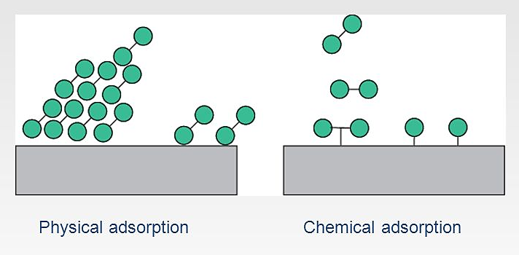

**Figure 1.4**. Physisorption



**Figure 1.5**. Chemisorption

Adsorption technology is achieving a prominent place among other wastewater treatment technologies in the recent world because it can generate high-quality water while being an economically feasible process.

The adsorption process is influenced by several characteristics of the adsorbent such as surface area, size distribution, pore size, density, and surface charge. Consequently, there has been a huge interest regarding the development of new adsorbent substances having various functionalities, diverse compositions, and properties66.

Activated carbon is considered the most effective and commonly used adsorbent. However, the major disadvantage of commercial activated carbon is its high cost. Therefore many researchers around the world have focused on many low-cost alternative substituents to commercial activated carbon65.

In this study, adsorption properties of three types of tire char varieties (tire pyrolystic char, demineralized char, and activated char) on the removal of methylene blue have been investigated and compared with commercial carbon black as an initial step.

### Removal of Methylene blue dye (MB) by adsorption

As the initial stage of this study, pyrolysis tire char, demineralized tire char, and chemically activated tire char from waste tire pyrolysis were used as the adsorbents for the removal of methylene blue, a basic dye, from wastewater. Effects of various experimental parameters, such as adsorbent dosage ~~and~~, pH, contact time, and temperature were investigated.

Methylene blue dye

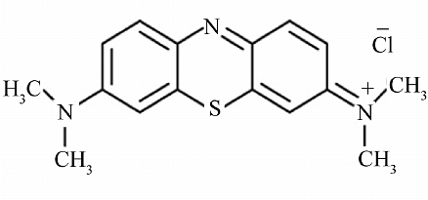

**Figure 1.6.** Structure of the methylene blue chloride salt

Methylene blue is selected in this study as a common dye used in industries such as textiles, paper, rubber, plastics, leather, cosmetics, pharmaceuticals, and food. As well as it has well-known high adsorption onto solids and can be utilized in identifying adsorptive content. Methylene blue is a heterocyclic aromatic chemical compound with the molecular formula C16H18N3SCl and the molecular weight of 319.85 g mol−1. It creates a blue color when dissolved in water. Because methylene blue acts as a cationic dye, it forms electrostatic bonds with negatively charged moieties80.

## Adsorption isotherms

Adsorption is a surface phenomenon that occurs when adsorbates migrate onto adsorbents. Adsorption technology has been widely used for water and wastewater treatment in recent decades due to its low cost, effectiveness, simplicity, and environmental friendliness. Chemical adsorption, which corresponds to the formation of chemical bonds, physical adsorption, which is related to the van der Waals force, and ion exchange are the most common adsorption mechanisms (Figure 1.7).

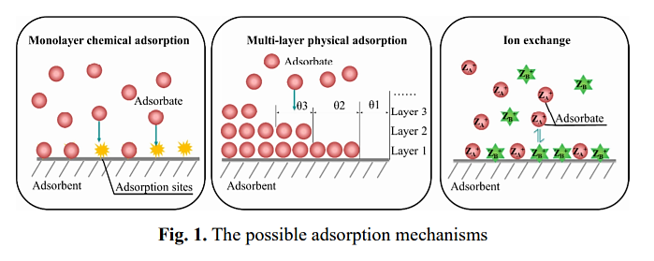

**Figure 1.7**. The possible adsorption mechanisms

The ability to develop adsorbents and adsorption systems requires a thorough understanding of adsorption mechanisms. Modeling of adsorption equilibrium data, characterization of adsorbent before and after adsorption, molecular dynamics analysis, and density functional theory (DFT) measurement have all been used to investigate adsorption mechanisms. At a given temperature, an isotherm describes the relationship between equilibrium adsorbate amounts in the liquid phase and equilibrium adsorption amount on the solid phase. We can use isotherms to model equilibrium adsorption data and investigate adsorption information such as adsorption mechanisms, maximum adsorption capacity, and adsorbent properties.

There are two adsorption empirical isotherms.

* Langmuir isotherm
* Freundlich isotherm

The equilibrium state of monolayer homogeneous adsorption is defined by the Langmuir model as shown in Figure1.8. The Langmuir isotherm is based on the following assumptions:

* Monolayer adsorption
* Homogeneous distribution of adsorption sites
* Constant adsorption energy
* Negligible interaction between adsorbate molecules

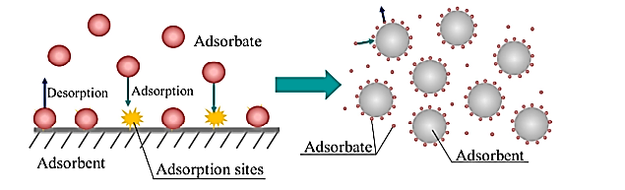

**Figure 1.8**. The adsorption mechanism reveals by the Langmuir isotherm model

The adsorbent materials are homogeneous in macroscopic view in most adsorption methods, and the solution is homogeneous with agitation. Even if the adsorbent materials have irregular shapes and non-uniform surfaces in the microscope, the Langmuir isotherm can still reflect adsorption. The Langmuir model can also be used to model monolayer adsorption on surfaces and in the pores of the adsorbent. This could explain why the Langmuir isotherm can adequately reflect equilibrium data. The Freundlich isotherm can be used to represent multi-layer adsorption on heterogamous surfaces.

In this research, methylene blue dye adsorption by different tire char adsorbents has been described by using Langmuir isotherm and Freundlich isotherm models.

## Desorption/Regeneration studies

The problem of dye-loaded adsorbents is also difficult since the continuous accumulation of contaminants on the adsorbents progressively decreases the adsorbent's overall adsorption performance and also has an environmental impact due to adsorbate leaching81. Adsorbent regeneration is critical; using the right technique increases adsorption efficiency by eliminating contaminants, lowers overall treatment costs, reduces produced waste, and solves the disposal problem. Chemical, thermal, supercritical extraction, photocatalytic, and biological techniques are the most popular and widely used regeneration techniques, according to literature reviews.

Stability and reusability are important characteristics for ideal adsorbents in large-scale industrial applications82. Desorption studies can be carried out to elucidate the nature of the adsorption process and as well as the recycling/reusability of the spent10. A proper selection of eluents is required for a better desorption process. Dilute acids like HCl and $H_{2}{SO}_{4}$ have been extensively utilized for the desorption of basic dyes. However thermal desorption method has been not widely used for desorption studies according to the literature. But it can be considered as one of the best desorption methods in recent.

## Research problem

Tire pyrolysis char is a waste and its disposal is problematic. Water is a valuable resource and it is polluted by many synthetic dyes. The removal of these dyes from water resources is also a huge challenge and it leads to a shortage of fresh and clean water and many other problems to nature. However, tire-derived char which is a waste in many tire industries can be used to remove the dye contaminants from wastewater by using the process of adsorption. As an initial attempt of the research, methylene blue was used as the dye and it was allowed to adsorb on different pyrolysis char types having different modifications at different conditions to investigate the adsorption characteristics of pyrolysis char for the treatment of waste water-bearing dyes.

CHAPTER 02

# Materials and methods

## Apparatus

The pyrolysis char for this investigation was obtained by Revoga (Pvt) Ltd, Puttalam. It was demineralized by GPR grade HCl and NaOH. GPR grade KOH was used for the chemical activation of pyrolytic char. The prepared adsorbents together with commercial carbon black were used to investigate the adsorption behavior of methylene blue dye on the laboratory scale. The adsorption and desorption studies were performed using Edmund Buhler 7400 rotary shaker set to 120 rpm. The pH measurements were made using a JANEWAY 3505 pH meter. An electronic balance with an accuracy of 0.0001 g was used for taking the weights of dye, adsorbents, and other chemicals used in the research. The equilibrium solutions were filtered using Whatman No: 01 (pore size-11 $μm$) filter paper and the absorbance of the filtrates were measured using UH 5300 HITACHI UV /Visible spectrophotometer at 664 nm, $λ_{max}$ for methylene blue (MB).

## Batch adsorption experiments

The effects of experimental parameters such as adsorbent dosage, pH, temperature, and contact time on dye adsorption by tire pyrolysis char, demineralized tire char, activated tire char, and commercial carbon black were studied in batch adsorption experiments. All the experiments were carried out at room temperature except for the experiments which were conducted to examine the effect of temperature on the adsorption process.

All batch adsorption experiments were conducted in 250 mL reagent bottles except pH experiments (used 250 mL conical flasks) with 50 mL of methylene blue dye solutions with the desired concentrations. The solutions were mechanically agitated in a shaker at 120 rpm. The absorbance of the equilibrium solutions was determined by a UV/Visible spectrophotometer. The methylene blue concentrations at equilibrium were calculated from a methylene blue calibration curve. Desorption studies were carried out thermally to study the repeatability of the adsorbent.

The amount of methylene blue dye adsorbed per gram of adsorbent at equilibrium ($q_{e})$ and the percentage removal of dye was determined by the following equations.

${ q}_{e}$ = $\frac{ C_{0}-C_{e}}{m}$ $×$ v

% Removal = $\frac{ {(C}_{0}-C_{e}) × 100}{C_{0}}$

$C_{0}$ = Initial methylene blue dye concentration (mg/L)

$C_{e}$ =Equilibrium methylene blue dye concentration (mg/L)

V=Volume of methylene blue solution (L)

m=Dry weight of the adsorbent used (g)

Finally, the equilibrium data were fitted to Langmuir and Freundlich isotherm models to calculate the maximum adsorption capacities and adsorption intensities of the adsorbents.

## Preparation of reagents

All the reagents used were of GPR grade: potassium hydroxide, sodium hydroxide, hydrochloric acid, and methylene blue. Methylene blue was selected due to its strong adsorption onto solid surfaces.

### Preparation of methylene blue solutions

A stock solution 1000 mg/L of methylene blue solution was prepared by dissolving an accurately weighed 1.0000 $±$ 0.0001 g of dye in 1 L deionized water. The desired concentrations for batch adsorption experiments were obtained by appropriate dilutions.

### Preparation of NaOH and HCl solutions.

#### Preparation of 0.1 M HCl solution

An aliquot of 2 mL of concentrated HCl was diluted in a 250 mL volumetric flask with deionized water.

#### Preparation of 0.1 M NaOH solution

The solution was prepared by dissolving 1.02 g of sodium hydroxide pellets in a 250 mL volumetric flask with deionized water.

#### Preparation of 1 M HCl solution

An aliquot of 20 mL of concentrated HCl was diluted in a 250 mL volumetric flask with deionized water.

#### Preparation of 2 M HCl solution

An aliquot of 82 mL of concentrated HCl was diluted in a 500 mL volumetric flask with deionized water.

#### Preparation of 2 M NaOH solution

The solution was prepared by dissolving 20.40 g of sodium hydroxide pellets in a 250 mL volumetric flask with deionized water.

## Pretreatment of pyrolysis tire char Sieving process

An amount of 500 g (approximately) of pyrolysis char was measured and it was sieved through 200 $μm$ mesh for separating the particles having less than 200 $μm$.

## Adsorbent development

Tire pyrolysis char was pretreated initially by sieving and then modified into two different types of char by demineralization and activation processes.

### Demineralized tire char preparation

An amount of 100 g of pre-treated (sieved) sample was measured into a 1 L beaker and 200 mL of 2 M HCl was added to it. This was stirred keeping on the magnetic stirrer at 200 rpm for 1 h at 60 °C. The sample was filtered using the Buchner funnel and washed with deionized water. The same procedure was followed for the same sample again and the filtered sample was washed with 200 mL of 2 M NaOH keeping on the magnetic stirrer at 200 rpm for 1 h at 60 °C and then the filtered sample was washed with deionized water to get a neutral sample. Then the sample was dried at 110 °C in the oven until it gets a constant mass83.

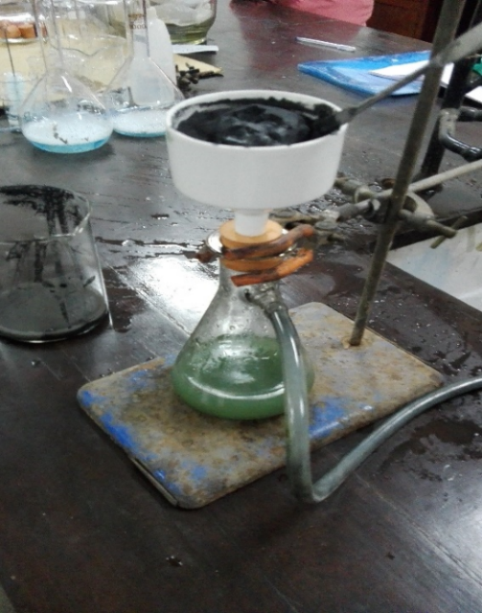

**Figure 2.1**. First wash with 2 M HCl

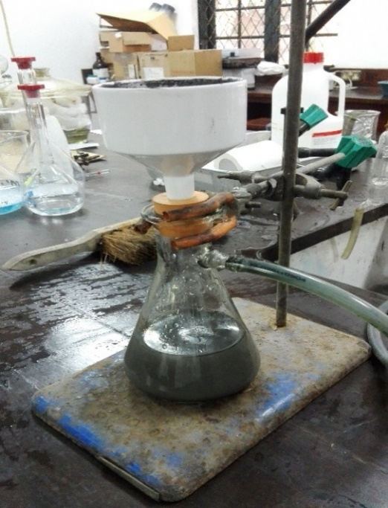

**Figure 2.2.** Second wash with 2 M HCl

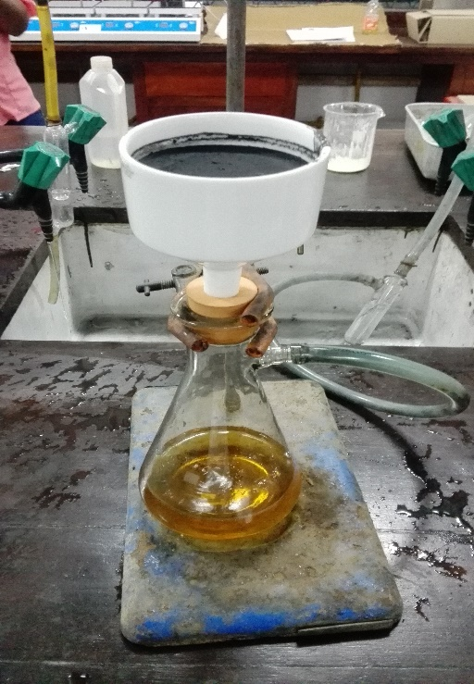

**Figure 2.3**. Third wash with 2 M NaOH

### Activation of demineralized tire pyrolytic char

An amount of 50 g of demineralized sample was impregnated with 500 mL aqueous solution of KOH at an impregnation ratio of 4:1 (weight of KOH: weight of char) and the mixture was stirred at 80 $℃$ for 4 hours to complete the impregnation process. The slurry produced from the impregnation process was dried in a drying oven at 100 $℃$ for 24 hours to remove moisture. Then 100 mL of distilled water was added to the sample and it was mixed well. The sample was then filtered using Whatman No: 01 filter paper (pore size of 11 $μm )$. The sample was dried at 100 $℃ for$ 4 hours. The dried sample was activated in a muffle furnace at a temperature of 600 $℃$ for 1 hour under an inert atmosphere. After the activation, the sample was washed with 250 mL of 2 M solution of HCl to remove ash and sulphur content and thereafter dried overnight.

## Char characterization

Ultimate analysis was performed on pyrolytic tire char, demineralized tire char and, activated tire char to determine the percentages of carbon, hydrogen, and nitrogen using a CHN analyzer based on the “Dumas method,” which entails the total and instantaneous oxidation of the sample utilizing “Flash combustion.” A chromatographic column separates the combustion products, which are then measured by a thermal conductivity detector (T.C.D.).The proximate analysis was performed on the above mentioned adsorbents to study thermal behaviors and to determine moisture content, volatiles, fixed carbon content, by using Perkin Elmer TGA 4000 machine and software. An amount of 10-20 mg of sample was placed on the sample holder maximizing the surface area of the sample in TGA pan and the thermal analysis was done. The XRD analysis was done using the Rigaku Ultima 4 XRD machine and TDXL 2 software. A small amount of adsorbent sample was placed on the sample holder and the sample was irradiated with incident X-rays. The intensities and scattering angles of the X-rays that are scattered by the material were measured. The surface morphology of the adsorbents were analyzed by using ZEIZZ EVO 18 SEM-EDX machine.

## Determination of the effect of adsorbent dosage on adsorption of methylene blue by different char types

### Tire pyrolysis char

To investigate the effect of pyrolysis tire char dosage on the removal of methylene blue dye, a series of adsorbent dosages were taken from 0.05 ~~g~~ – 1 g, and they were added to 50 mL of methylene blue solutions having an initial concentration of 10 ppm. The solutions were agitated in a shaker at 120 rpm for 15 minutes at room temperature. Then the solutions were filtered using Whatman filter papers (pore size of 11 and the filtrates were used to measure the absorbance using a UV/visible spectrophotometer. Finally, equilibrium methylene blue concentrations were determined.

### Demineralized tire char

To study the effect of demineralized tire char dosage on methylene blue dye removal, a series of adsorbent dosages were taken from 0.05 g – 1 g, and they were added to 50 mL of methylene blue solutions having an initial concentration of 20 ppm. The solutions were agitated in a shaker at 120 rpm for 15 minutes at room temperature. Then the solutions were filtered using Whatman filter papers (pore size of 11 ) and the filtrates were used to measure the absorbance using a UV/visible spectrophotometer. Finally, equilibrium methylene blue concentrations were determined.

### Activated tire char

To determine the effect of activated tire char dosage on methylene blue dye removal, a series of adsorbent dosages were taken from 0.05 g – 1 g, and they were added to 50 mL of methylene blue solutions having an initial concentration of 50 ppm. The solutions were agitated in a shaker at 120 rpm for 15 minutes at room temperature. Then the solutions were filtered using Whatman filter papers (pore size of 11 $μm$) and they were used to measure the absorbance using UV/Visible spectrophotometer. Finally, equilibrium methylene blue concentrations were determined.

### Commercial carbon black

To examine the effect of commercial carbon black dosage on methylene blue dye removal, a series of adsorbent dosages were taken from 0.05 g – 1 g, and they were added to 50 mL of methylene blue solutions having an initial concentration of 50 ppm. The solutions were agitated in a shaker at 120 rpm for 15 minutes at room temperature. Then the solutions were filtered using Whatman filter papers (pore size of 11 $μm)$ used to measure the absorbance using UV/Visible spectrophotometer. Finally, equilibrium methylene blue concentrations were determined

## Determination of the effect of contact time on adsorption of methylene blue dye on different char types

### Tire pyrolysis char

To determine the effect of contact time on methylene blue dye removal, 0.7 g of pyrolysis tire char was added to 50 mL solutions of an initial MB concentration of 10 ppm. The solution mixtures were agitated in a shaker at 120 rpm for different contact periods (5, 10, 15, 20, 25 and, 30 minutes) at room temperature. After agitating the solution mixtures for relevant contact periods, the solutions were filtered using Whatman filter papers (pore size of 11 and the filtrates were used to measure the absorbance using UV/visible spectrophotometer. Finally, equilibrium methylene blue concentrations were determined.

### Demineralized tire char

To investigate the effect of contact time, 0.2 g of demineralized tire char was added to 50 mL methylene blue solutions of an initial concentration of 20 ppm. The solution mixtures were agitated in a shaker at 120 rpm for different contact periods (5, 10, 15, 20, 25 and, 30 minutes). The experiment was carried out at room temperature. After agitating the solution mixtures for relevant contact periods, the solutions were filtered using Whatman filter papers (pore size of 11 ), and the filtrates were used to measure the absorbance using UV/visible spectrophotometer. Finally, equilibrium methylene blue concentrations were determined.

### Activated tire char

To determine the effect of contact time, 0.1 g of activated tire char was added to 50 mL methylene blue solutions of an initial concentration of 50 ppm. The solution mixtures were agitated in a shaker at 120 rpm for different contact periods (5, 10, 15, 20, 25 and, 30 minutes). The experiment was carried out at room temperature. After agitating the solution mixtures at 120 rpm in a shaker for relevant contact periods, the solutions were filtered using Whatman filter papers $(pore size of 11 μm),$ and the filtrates were used to measure the absorbance using UV/visible spectrophotometer. Finally, equilibrium methylene blue concentrations were determined.

### Commercial carbon black

To investigate the effect of contact time, 0.4 g of commercial carbon black was added to 50 mL solutions of an initial MB concentration of 50 ppm. The solution mixtures were agitated in a shaker at 120 rpm for different contact periods (5, 10, 15, 20, 25, and, 30 minutes). The experiment was carried out at room temperature. After agitating the solution mixtures at relevant contact periods at 120 rpm, the solutions were filtered using Whatman filter papers (pore size of 11 $μm$), and the filtrates were used to measure the absorbance using UV/visible spectrophotometer. Finally, equilibrium methylene blue concentrations were determined.

## Determination of the effect of pH on adsorption of methylene blue by different char types.

### Tire pyrolysis char

To determine the effect of pH on the adsorption process of methylene blue on normal pyrolysis char, 0.4 g of tire pyrolysis char was added to 50 mL of 10 ppm methylene blue solutions with adjusted pH of 2, 4, 6, 8 and, 10. They were agitated in a shaker for 20 minutes. Then the solutions were filtered using Whatman filter papers (pore size of 11 $μm$). The absorbance of the methylene blue solutions was measured using a UV/visible spectrophotometer to determine the equilibrium concentrations of methylene blue solutions. The pH of the solutions was adjusted with 0.1 M NaOH and 0.1 M HCl and measured using pH meter.

### Demineralized tire char

To determine the effect of pH on the adsorption process of methylene blue on demineralized tire char, 0.2 g of demineralized tire char was added to 50 mL of 20 ppm methylene blue solutions with adjusted pH of 2, 4, 6, 8 and, 10. They were agitated in an orbital shaker for 20 minutes at 120 rpm. Then the solutions were filtered using Whatman filter papers (pore size of 11). The absorbance of the methylene blue solutions was measured using a UV/visible spectrophotometer to determine the equilibrium concentrations of methylene blue solutions. The pH of the solutions was adjusted with 0.1 M NaOH and 0.1 M HCl and measured using pH meter.

### Activated tire char

To determine the effect of pH on the adsorption process of methylene blue on activated tire char, 0.1 g of activated tire char was added to 50 mL of 50 ppm methylene blue solutions with adjusted pH of 2, 4, 6, 8 and 10. They were agitated in a shaker for 20 minutes at 120 rpm. Then the solutions were filtered using Whatman filter papers (pore size of 11 $μm$). The absorbance of the methylene blue solutions was measured using a UV/visible spectrophotometer to determine the equilibrium concentrations of methylene blue solutions. The pH of the solutions was adjusted with 0.1 M NaOH and 0.1 M HCl and measured using pH meter.

### Commercial carbon black

To determine the effect of pH on the adsorption process of methylene blue on commercial carbon black, 0.4 g of commercial carbon black was added to 50 mL of 50 ppm methylene blue solutions with adjusted pH of 2, 4, 6, 8 and, 10. They were agitated in an orbital shaker for 20 minutes at 120 rpm. Then the solutions were filtered using Whatman filter papers (pore size of 11). The absorbance of the methylene blue solutions was measured using a UV/visible spectrophotometer to determine the equilibrium concentrations of methylene blue solutions. The pH of the solutions was adjusted with 0.1 M NaOH and 0.1 M HCl and measured using pH meter.

## Determination of the effect of temperature on adsorption of methylene blue by different char types

### Tire pyrolysis char

To determine the effect of temperature, 0.3 g of pyrolysis tire char was added to each 50 mL of 10ppm methylene blue solution with an adjusted temperature of, 30, 40, 50, 60, 70 and, 80 $℃$. After a shaking time of 20 minutes in a shaker at 120 rpm, the solutions were filtered using Whatman filter papers (pore size of 11 $μm),$ and finally, the absorbance of the equilibrium solutions was measured using UV/visible spectrophotometer.

### Demineralized tire char

To determine the effect of temperature, 0.2 g of demineralized tire char was added to each 50 mL of 20 ppm methylene blue solutions with an adjusted temperature of 30 $℃$, 40 $℃$, 50 $℃$, 60 $℃$, 70 $℃$ and, 80 $℃$. After a shaking time of 20 minutes in a shaker at 120 rpm, the solutions were filtered using Whatman filter papers (pore size of 11 $μm$) and finally, the absorbance of equilibrium solutions was measured using a UV/visible spectrophotometer.

### Activated tire char

To determine the effect of temperature, 0.1 g of activated tire char was added to each 50 mL of 50 ppm methylene blue solution with an adjusted temperature of 30 $℃$, 40 $℃$, 50 $℃$, 60 $℃$, 70 $℃$ and, 80 $℃$. After a shaking time of 20 minutes in a shaker at 120 rpm, the solutions were filtered using Whatman filter papers (pore size of $11 μm),$ and finally, the absorbance of equilibrium solutions was measured using UV/visible spectrophotometer.

### Commercial carbon black

To determine the effect of temperature, 0.4 g of commercial carbon black was added to each 50 mL of 50 ppm methylene blue solution with an adjusted temperature of 30 $℃$, 40 $℃$, 50 $℃$, 60 $℃$, 70 $℃$ and, 80 $℃ .$ After a shaking time of 20 minutes in a shaker at 120 rpm, the solutions were filtered using Whatman filter papers (pore size of 11 $μm$), and finally, the absorbance of equilibrium solutions was measured using UV/visible spectrophotometer.

## Desorption studies

Demineralized char was used to study the repeatability of the adsorbent. About 10 reagent bottles were taken and 50 mL from 50 ppm methylene blue solution was added to each of the reagent bottles. Then, about 0.2 g of demineralized char was added to each of them. All the reagent bottles were agitated in a shaker at 120 rpm for 20 minutes. After 20 minutes of agitation period, all the solutions were mixed into one beaker and it was filtered using a Buchner funnel. The filtrate was taken and its absorbance was measured using a UV/visible spectrophotometer. The filtered demineralized char residue was taken and it was oven-dried at 100 $℃$ for 30 minutes to remove the excess moisture. Then, the residue was kept in a muffle furnace at 500 $℃$ for one hour for the thermal desorption process. About 0.2 g of thermally desorbed residue was then added to each of the 50 mL of 50 ppm methylene blue solutions. Then the solutions were heated to 40 $℃$ and agitated for 20 minutes in a shaker at 120 rpm. The absorbance of the equilibrium solutions was measured using a UV/visible spectrophotometer. Then the same process was followed six times to evaluate the repeatability.

CHAPTER 03

# Results and discussion

Tire pyrolytic char, demineralized tire char, and activated tire char were prepared and their initial characterization was done using CHN analysis, TGA (thermo gravimetric analysis), XRD (x-ray diffraction crystallography) and SEM (scanning electron microscopy). The factors affecting the adsorption of methylene blue dye by the prepared adsorbents such as adsorbent dosage, pH, contact time, and temperature were evaluated and compared with commercially available carbon black (N330). Regeneration of demineralized tire char by thermal desorption was carried out to study its potential for reuse.

## Char characterization

### Ultimate analysis of prepared adsorbents.

An elemental analyzer (EA) was used to perform an ultimate analysis (CHN) on pyrolytic tire char, demineralized tire char and activated tire char. Due to calibration limitations, sulfur and oxygen were not evaluated using EA. Table 3.1 indicates the CHN analysis of the three adsorbents.

**Table 3.1**. CHN analysis of adsorbents

|  |  |  |  |
| --- | --- | --- | --- |
| Type of char | C (wt.%) | H (wt.%) | N (wt.%) |
| Tire pyrolytic char | 65.03 | 0.27 | 0.21 |
| Demineralized tire char | 74.15 | 0.61 | 0.17 |
| Activated tire char | 77.30 | 0.27 | 0.02 |

As shown in Table 3.1, the carbon content of tire pyrolytic char was 65.03 wt.%. According to Lopez et al., the carbon content of the tire pyrolytic char was 81.5 % which is higher than that of tire pyrolytic char utilized in the present study84.This difference can be due to the high amount of impurities present in the feed stocks which was used in the present study. The carbon content of demineralized char and activated tire char was approximately 74% and 77% respectively which is lower than the carbon content of the same adsorbents(demineralized tire char and activated tire char) reported by Lopez et al.84. They have reported a carbon content of 86.1% and 84.9 % for demineralized tire char and activated tire char respectively. However, carbon content has been increased by approximately 9% upon demineralization and 12% upon activation of tire pyrolytic char according to the present study. When upgrading tire pyrolytic char into demineralized tire char and activated tire char, the impurities which were present in the initial tire pyrolytic char have been reduced to a certain extent. The hydrogen content of demineralized tire char has become significantly higher than that of pyrolytic tire char and activated tire char while nitrogen content of activated tire char was lower than that of demineralized tire char and pyrolytic tire char. According to literature, excess nitrogen on activated carbon has been linked to the formation of mesoporosity, which reduces micropores and specific surface area85. For higher char yields, carbon content in the range of 40%–90% is preferable in the manufacture of activated carbon whereas low sulfur and nitrogen concentrations in a precursor are chosen to avoid emissions from these elements' oxides during pyrolysis86. These oxides have a negative impact on the environment86. Therefore, the activated tire char developed in this study has a greater specific surface area and can reduce hazardous emissions into the atmosphere since it has a lower nitrogen content than the other two adsorbents.

### Proximate analysis

#### Thermogravimetric Analysis

#### 

Thermogravimetric analysis (TGA) measures weight changes in a substance as a function of temperature (or time) in a controlled atmosphere. Measurement of a material's thermal stability, moisture and solvent content, and the percent composition of components in a compound are some of its main applications. Thermogravimetry (TG) and derivative thermogravimetry (DTG) curves were obtained with a thermogravimetric test of adsorbent samples of tire pyrolysis char, demineralized tire, and activated tire char under a nitrogen environment and constant heating rate up to 900°C are shown in Figures 3.1, 3.2, and 3.3 respectively. According to the Figure 3.1 given for tire pyrolytic char, moisture and the low molecular weight compounds on the surface were removed from the sample up to around 400 $℃$ and the thermal degradation of the structure was stabilized. Around the temperature of 480 $℃$, a mass loss of 65 % occurred, remaining 35 % of the carbonaceous char residue. It still lost around (1-2)% of its mass up to 900 $℃$, denoting some unconverted carbon87.

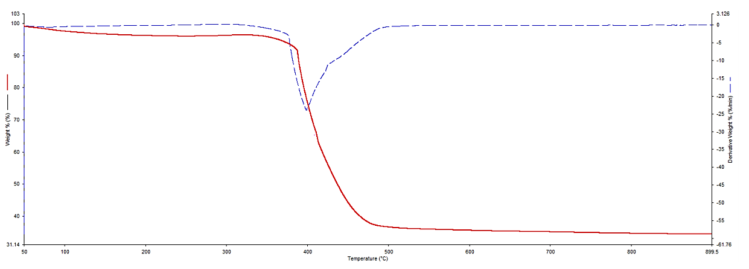

**Figure 3.1.** TGA spectrum of tire pyrolytic char

According to the TGA curve of demineralized tire char (Figure 3.2), moisture and other low molecular components were liberated from the sample upto 500 $℃$ and the structure was stable up to that temperature without degradation. However, a mass loss of 85% of demineralized tire char occurred between 500 $℃$-600 $℃$ temperatures, remaining around 15% of the carbonaceous residue

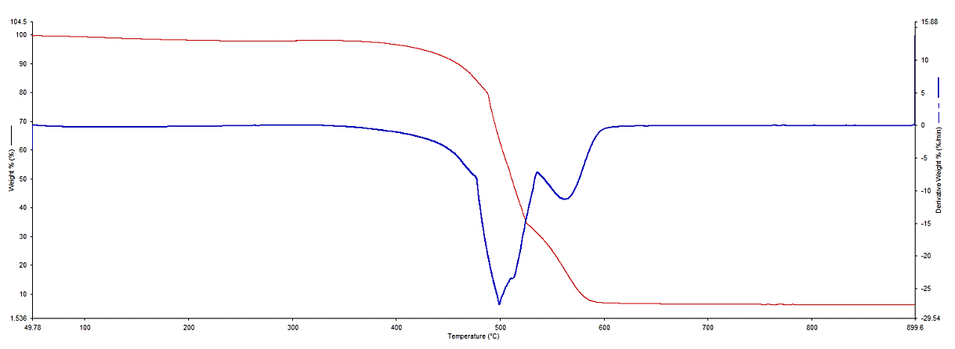

**Figure 3.2**. TGA spectrum of demineralized tire char

At 350 $℃$, the activated tire char starts to degrade upon increasing the temperature (Figure 3.3). A mass loss of 90% of activated tire char occurred between 350 $℃$- 500 $℃$ temperatures and approximately 10% of the carbonaceous compound has resided. The weight loss suffered by activated carbon was minimal and occurred at a slower rate at temperatures exceeding 500°C. The significant difference in weight loss between the tire pyrolysis char activated tire char samples can be recognized. The chemically activated char lost more weight because the KOH employed in the impregnation of the char acts as a dehydrating agent, allowing more volatile stuff existing in the char to be ejected out and thus more pores to be formed at the surface, which can increase the adsorption process. As a base, KOH can eliminate a large number of inorganic impurities, resulting in a high carbon yield.

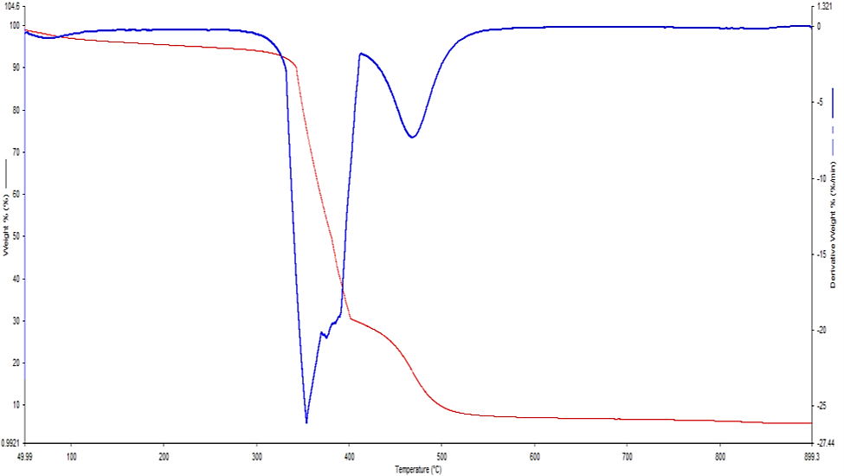

**Figure 3.3**. TGA spectrum of activated tire char

Figure 3.4 represents the TGA spectrum of commercial carbon black. It can be seen that commercial carbon black (N330) begins to degrade at 400°C and continues to degrade as the temperature rises. Between 400 °C and 550 °C, 90% of the mass of commercial carbon black was lost, and approximately 5 % of the carbonaceous compound remained.

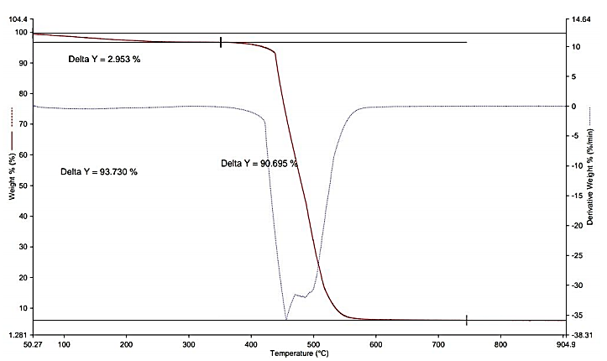

**Figure 3.4**. TGA spectrum of commercial carbon black (N330)

According to the thermogravimetric analysis of the all adsorbents, it can be observed that, demineralized char and commercial carbon black have their maximum thermal stabilities at 400 $℃$ whereas tire pyrolytic char and activated tire char have their thermal stabilities at 500 $℃,$ and 350 $℃$ temperatures respectively.

Table 3.2 illustrates the TGA data representing moisture content and other volatiles, ash content and the fixed carbon content of the tire pyrolytic char, demineralized tire, activated tire char and commercially available carbon black (N330). It can be seen that demineralized tire char has the lowest moisture content and highest fixed carbon content compared to other adsorbents whereas the ash content is lowest in commercially available carbon black (N330). The high ash content of tire pyrolytic char can be due the impurities and other inorganic substances in the feedstock. During demineralization of tire pyrolytic char, a lot of impurities and other inorganic substances are eliminated resulting in a very low amount of ash content. However, the ash formed in the demineralized char and activated tire char could be carbon derived. The moisture content of all adsorbents should be removed prior to the adsorption experiments. It is clear that the demineralized tire char and activated tire char developed in this work have improved chemical characteristics than commercially available carbon black (N330) for an efficient adsorption process.

**Table 3.2**. Proximate analysis-TGA analysis of tire pyrolytic char, demineralized tire char and activated tire char

|  |  |  |  |
| --- | --- | --- | --- |
| Type of char | Moisture/wt.% | Ash/wt.% | Fixed carbon/wt. % |
| Tire pyrolytic char | 3.67 | 36.59 | 87.32 |
| Demineralized tire char | 1.95 | 6.98 | 91.78 |
| Activated tire char | 5.01 | 9.71 | 90.93 |
| Commercial carbon black(N330) | 2.953 | 6.27 | 90.69 |

### XRD Analysis

The XRD analysis allowed the main crystalline mineral phases in the char composition to be identified. Figures 3.5, 3.6 and 3.7 represent the X-ray diffraction patterns of tire pyrolytic char, demineralized tire char and activated tire char respectively.

The XRD pattern of tire pyrolytic char shown in Figure 3.5 is typical of tire-derived chars and peaks are primarily due to zinc sulfide (ZnS)87 . ZnS peaks are mainly attributed to zinc sulfides wurtzite ($α$-ZnS) and sphalerite ($β$-ZnS) crystalline phases 88. The presence of the wurtzite and sphalerite crystal phases may be seen in the strong peak at 2=36° 89.

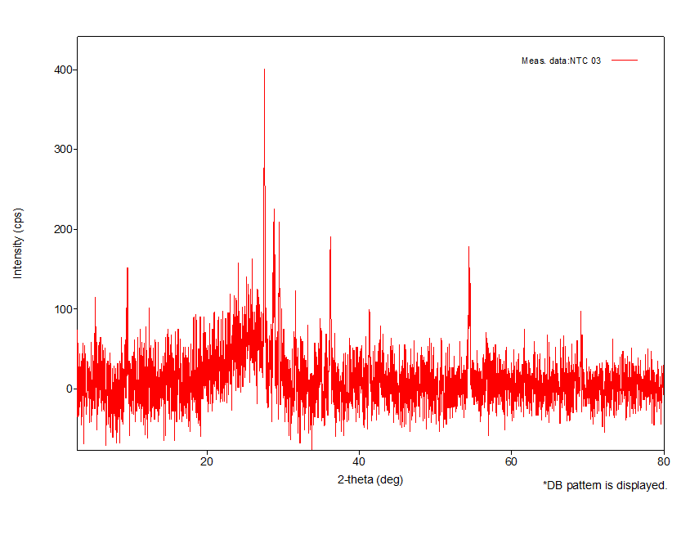

**Figure 3.5**. X-ray diffraction patterns of tire pyrolytic char

However, the number peaks due to ZnS have reduced in demineralized tire char (figure 3.6) compared to tire pyrolytic char. The generation of ZnS is owed to the reaction of ZnO which is used as an accelerator for rubber vulcanization process undergoes sulfidation with hydrogen sulfide ($H_{2}S$) generated during pyrolysis process87.

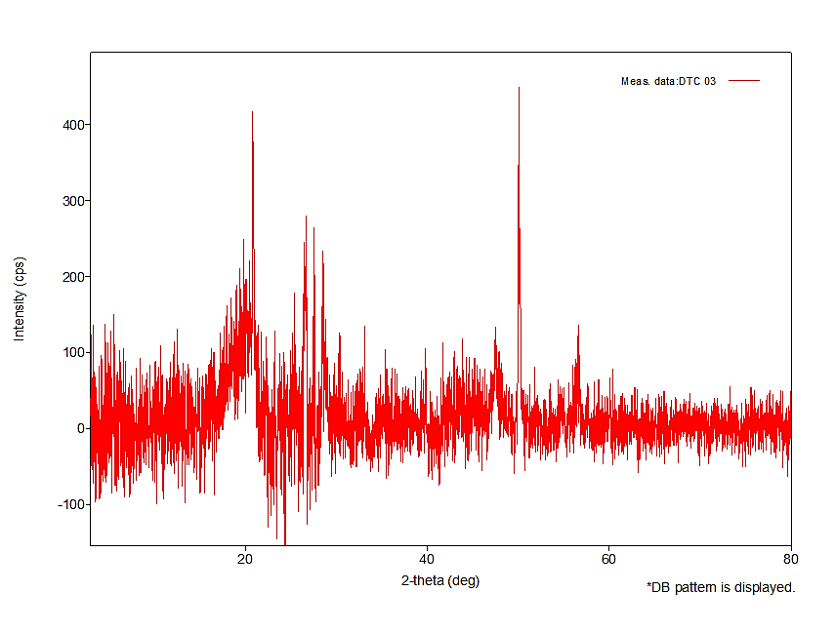

**Figure 3.6**. X-ray diffraction patterns of demineralized tire char

The main peaks centered at $2θ\sim$ 26 $°$ are characteristic of layered graphic s $p^{2}$-domains while broad peaks correlate to amorphous $sp^{2}$/ $sp^{3}$ domains. According to the XRD pattern of activated tire char shown in Figure 3.7, it can be seen that, the broad peaks between 15 $°$ and 30 $°$ and 40 $°$ and 50 $°$ (2 $θ$) are correlated with an amorphous carbon structure with randomly organized graphite-like microcrystalline structures87. According to the literature, amorphous structure of carbon is considered to be an advantageous property for adsorption applications90

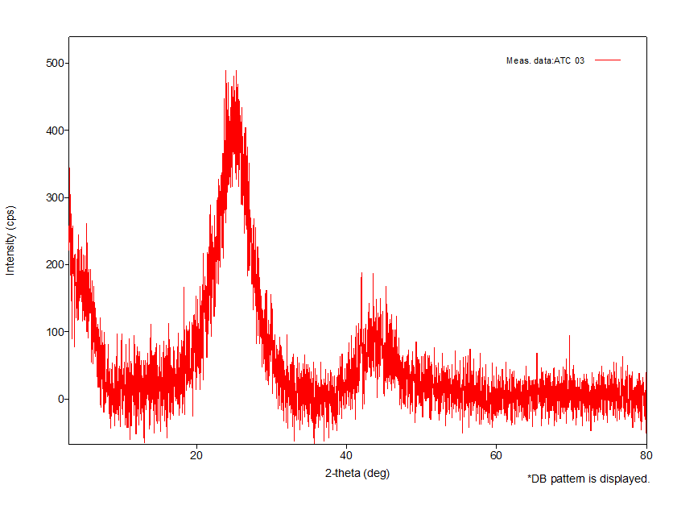

**Figure 3.7**. X-ray diffraction patterns of activated tire char

### Surface morphology

The morphology of the sample under investigation is determined via SEM (scanning electron microscopy). A sample is scanned with a focused beam of electrons to create images. When electrons contact atoms of the sample, they produce a variety of signals that may be detected and carry information about the surface topography and composition of the sample. In most cases, the electron beam is scanned in a raster scan pattern, and the position of the beam is coupled with the detected signal to create a picture.

The surface structure of the samples was discovered using a scanning electron microscope. Figures 3.8, 3.9 and, 3.10 show SEM images of tire pyrolytic char, demineralized tire char and activated tire char respectively. Scanning electron microscopic images of the adsorbent surface were taken at various magnification levels. At increased magnification, the well-developed porous surface could be seen in all of the cases. All of the adsorbents have a rough texture with a heterogeneous surface and a diversity of randomly dispersed pore sizes allowing for a broad surface area for methylene blue adsorption as seen in the images. However, the large particle size and impurities on the surface of tire pyrolysis char (Figures 3.8a-c) can cause inefficient adsorption compared to demineralized tire char and activated tire char.

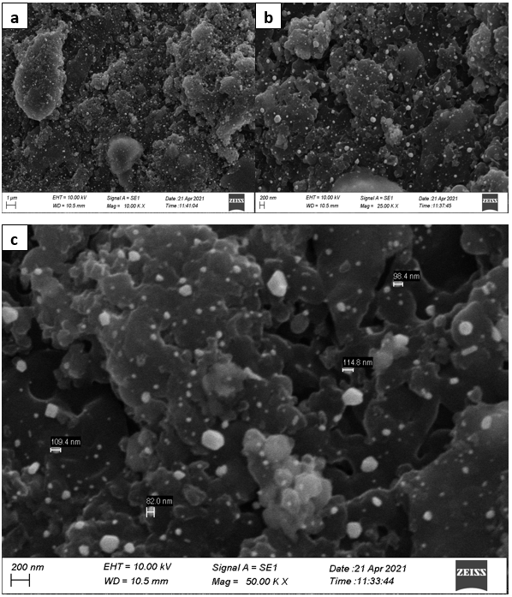

**Figure 3.8**. SEM images of tire pyrolytic char

Based on a comparison of all the figures, the samples prepared from demineralized tire char (Figures 3.9d-f) and activated tire char (Figures 3.10g-i) have a highly porous structure that becomes visible as the magnification level rises when compared with tire pyrolytic char. It is obvious from these diagrams that dye molecules have a good chance of adsorbing into these pores. It is apparent that a greater amount of impurities which were appeared in the tire pyrolytic char has been reduced upon demineralization and activation.

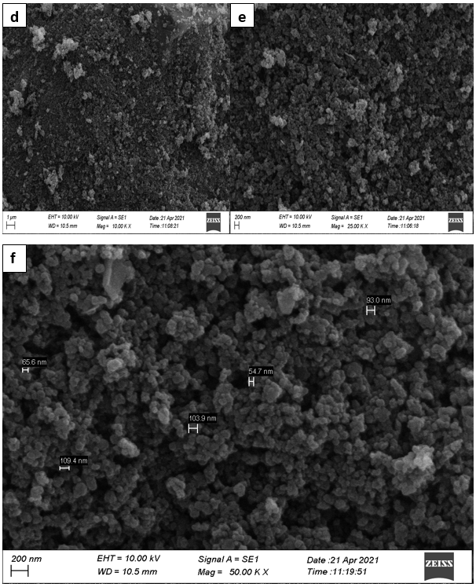

**Figure 3.9**. SEM images of demineralized tire char

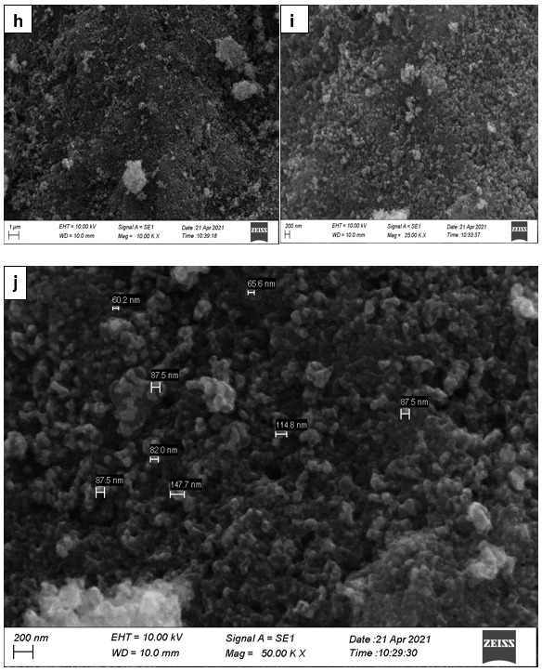

**Figure 3.10**. SEM images of activated tire char

## Effect of adsorbent dosage

The effect of adsorbent dosage on removal of methylene blue dye by tire pyrolytic char was determined by varying the adsorbent dosages from 0.005 g to 1 g per 50 mL of 10 ppm methylene blue solution. The experiment was performed in triplicate. Final absorbance, the concentrations of the methylene blue solutions and the dye removal percentage at each adsorbent dose of pyrolytic tire char are given in table 3.3.

**Table 3.3**. Average data for the determination of effect of adsorbent dosage on removal of methylene blue dye at various adsorbent dosages of tire pyrolytic char. Experimental conditions-Agitating speed: 120 rpm, Contact time: 15 min, Temperature: 29

Initial absorbance – 1.895

|  |  |  |  |
| --- | --- | --- | --- |
| Adsorbent dosage per 50 mL of 10 ppm methylene blue solutions(W $±$ 0.0001) | Final absorbance  (A $±$ 0.001) | Final methylene blue concentration/ppm | % Dye removal |
| 0.0050 | 0.706 | 3.44 | 65.56 $±$ 0.02 |
| 0.0501 | 0.686 | 3.34 | 66.53 $±$ 0.01 |
| 0.1000 | 0.601 | 2.93 | 70.68 $±$ 0.01 |
| 0.2000 | 0.395 | 1.93 | 80.73 $±$ 0.03 |
| 0.3000 | 0.218 | 1.06 | 89.36 $±$ 0.03 |
| 0.4001 | 0.099 | 0.48 | 95.17 $±$ 0.03 |
| 0.5002 | 0.084 | 0.41 | 95.90 $±$ 0.03 |
| 0.6000 | 0.039 | 0.20 | 98.05 $±$ 0.01 |
| 0.7001 | 0.007 | 0.04 | 99.62 $±$ 0.03 |
| 0.8000 | 0.006 | 0.03 | 99.72 $±$ 0.04 |
| 0.9001 | 0.03 | 0.02 | 99.83 $±$ 0.02 |
| 1.0000 | 0.03 | 0.02 | 99.83 $±$ 0.05 |

By adjusting the adsorbent dosages from 0.005 g to 1 g per 50 mL of 20 ppm methylene blue solution, the effect of adsorbent dosage on the removal of methylene blue dye by demineralized tire char was evaluated. The experiment was done in triplicate. Table 3.4 shows the final absorbance, the final methylene blue solution’s concentration, and dye removal percentage for each adsorbent dose of demineralized tire char.

**Table 3.4**. Average data for the determination of effect of adsorbent dosage on removal of methylene blue dye at various adsorbent dosages of demineralized tire char. Experimental Conditions-Agitating speed: 120rpm, Contact time: 15min, Temperature: 29 $℃$

Initial absorbance – 2.984

|  |  |  |  |
| --- | --- | --- | --- |
| Adsorbent dosage per 50 mL of 20 ppm methylene blue solutions(W $±$ 0.0001) | Final absorbance  (A $±$ 0.001) | Final methylene blue concentration/  ppm | % Dye removal |
| 0.0050 | 1.870 | 9.12 | 54.39 $±$ 0.01 |
| 0.0500 | 0.987 | 4.81 | 75.92 $±$ 0.02 |
| 0.1000 | 0.654 | 3.19 | 84.04 $±$ 0.02 |
| 0.2001 | 0.345 | 1.68 | 91.58 $±$ 0.05 |
| 0.3001 | 0.083 | 0.40 | 97.97 $±$ 0.02 |
| 0.4000 | 0.071 | 0.34 | 98.26 $±$ 0.04 |
| 0.5002 | 0.065 | 0.31 | 98.41 $±$ 0.03 |
| 0.6000 | 0.060 | 0.29 | 98.53 $±$ 0.03 |
| 0.7001 | 0.059 | 0.28 | 98.56 $±$ 0.02 |
| 0.8000 | 0.056 | 0.27 | 98.63 $±$ 0.04 |
| 0.9001 | 0.044 | 0.21 | 98.92 $±$ 0.03 |
| 1.0000 | 0.041 | 0.20 | 99.00 $±$ 0.02 |

Using adsorbent dosages ranging from 0.005 g to 1 g per 50 mL of 50 ppm methylene blue solution, the effect of adsorbent dosage on the removal of methylene blue dye by activated tire char was investigated. The experiment was done in triplicate. Table 3.5 shows the dye removal %, final absorbance, and concentration of methylene blue solutions at each adsorbent dose of activated tire char.

**Table 3.5.** Average data for the determination of effect of adsorbent dosage on removal of methylene blue dye at various adsorbent dosages of activated tire char. Experimental conditions-Agitating speed: 120rpm, Contact time: 15min, Temperature: 29 $℃$

Initial absorbance- 3.451

|  |  |  |  |
| --- | --- | --- | --- |
| Adsorbent dosage per 50 mL of 50 ppm methylene blue solutions(W $±$ 0.0001) | Final absorbance  (A $±$ 0.001) | Final methylene blue concentration/ppm | % Dye removal |
| 0.0050 | 3.228 | 15.74 | 68.50 $±$ 0.01 |
| 0.0500 | 2.613 | 12.75 | 74.50 $±$ 0.02 |
| 0.1001 | 0.527 | 2.57 | 94.85 $±$ 0.02 |
| 0.2000 | 0.039 | 0.19 | 99.61 $±$ 0.02 |
| 0.3000 | 0.032 | 0.16 | 99.68 $±$ 0.01 |
| 0.4001 | 0.029 | 0.14 | 99.71 $±$ 0.03 |
| 0.5000 | 0.022 | 0.10 | 99.78 $±$ 0.02 |
| 0.6000 | 0.015 | 0.07 | 99.85 $±$ 0.02 |
| 0.7001 | 0.018 | 0.08 | 99.82 $±$ 0.02 |
| 0.8000 | 0.019 | 0.09 | 99.81 $±$ 0.02 |
| 0.9000 | 0.014 | 0.07 | 99.86 $±$ 0.02 |
| 1.0000 | 0.012 | 0.06 | 99.88 $±$ 0.02 |

By adjusting the adsorbent dosages from 0.005g to 1 g per 50 mL of 50 ppm methylene blue solution, the effect of adsorbent dosage on methylene blue dye removal by commercial carbon black was evaluated. The experiment was carried out in triplicate. Table 3.6 shows the final absorbance, methylene blue solution concentrations, and dye removal percentages for each adsorbent dose of commercial carbon black.

**Table 3.6**. Average data for the determination of effect of adsorbent dosage on removal of methylene blue dye at various adsorbent dosages of commercial carbon black. Experimental conditions-Agitating speed: 120rpm, Contact time: 15min, Temperature: 29 $℃$

Initial absorbance-3.459

|  |  |  |  |
| --- | --- | --- | --- |
| Adsorbent dosage per 50 mL of 50 ppm methylene blue solutions(W $±$ 0.0001) | Final absorbance  (A $±$ 0.001) | Final methylene blue concentration/ppm | % Dye removal |
| 0.0050 | 3.274 | 15.97 | 68.05 $±$ 0.05 |
| 0.0500 | 3.231 | 15.76 | 68.47 $±$ 0.03 |
| 0.1001 | 3.104 | 15.14 | 69.71 $±$ 0.02 |
| 0.2001 | 2.165 | 10.56 | 78.87 $±$ 0.02 |
| 0.3000 | 1.093 | 5.33 | 89.33 $±$ 0.02 |
| 0.4002 | 0.762 | 3.72 | 92.56 $±$ 0.02 |
| 0.5000 | 0.370 | 1.80 | 96.39 $±$ 0.02 |
| 0.6001 | 0.236 | 1.15 | 97.69 $±$ 0.04 |
| 0.7000 | 0.108 | 0.53 | 98.94 $±$ 0.02 |
| 0.8001 | 0.067 | 0.33 | 99.34 $±$ 0.02 |
| 0.9000 | 0.065 | 0.32 | 99.36 $±$ 0.05 |
| 1.0002 | 0.019 | 0.09 | 99.81 $±$ 0.02 |

The adsorbent dosage is one of the major parameters because it concludes the capacity of an adsorbent for a given initial concentration.

The effect of the adsorbent dose on the removal of methylene blue was studied by varying the adsorbent dose from 0.005 g to 1.00 g per 50 mL $of methylene blue solution$ for all four adsorbents (tire pyrolytic char, demineralized char, activated tire char and commercial carbon black as shown in the Figure 3.11a-d.

**Figure 3.11**. Effect of adsorbent dosage on removal of methylene blue by tire pyrolytic char (a), demineralized tire char(b), activated tire char(c) and, commercial carbon black(d) (Agitating speed: 120 rpm, Contact time: 15 min, Temperature:29 $℃$)

It is evident that adsorbent dosage significantly influences the amount of dye adsorbed by the adsorbent or dye removal from the solutions. In all four adsorbent varieties, the dye removal is quite rapid initially, gradually slows down and reaches equilibrium. The initial increase of the dye removal percentage is probably due to a strong driving force, high surface area and increased availability of adsorption sites with the rise in adsorbent dose. This study demonstrates that optimum adsorbent doses may be established for specific dye concentrations.

According to the Figure 3.11, the optimum adsorbent dosage for tire pyrolytic char was approximately 0.7 g per 50 mL of 10 ppm of methylene blue solution for a maximum dye removal of 99.62%, while for commercial carbon black it was approximately 0.8 g per 50 mL of 50 ppm methylene blue solution for a maximum dye removal of 99.34%.

The adsorption capacity of tire pyrolysis char at 0.7 g per 50 mL of methylene blue dosage is 0.72 mg/g while it is 3.10 mg/g for commercial carbon black at its optimum dosage of 0.8g per 50 mL of 50 ppm of methylene blue solution.

The optimum adsorbent dosage for demineralized tire char is approximately 0.3 g per 50 mL of 20 ppm of methylene blue solution while its adsorption capacity at that optimum dosage is 3.26 mg/g aiding a maximum dye removal of 97.97%.The adsorption capacity of activated carbon is 12.45 mg/g at its optimum adsorbent dosage of 0.2 g per 50 mL of 50 ppm methylene blue solution which results in 99.61% dye removal. In comparison, activated carbon has the highest adsorbent capacity at its optimum adsorbent dosage. Table 3.7 indicates a summary of the adsorbent capacities at optimum dosage.

**Table 3.7**. Summary of adsorbent dosages at maximum dosage of adsorbents

|  |  |
| --- | --- |
| Adsorbent | Adsorbent capacity at maximum adsorbent  dosage (mg/g) |
| Pyrolytic char | 0.72 |
| Demineralized char | 3.26 |
| Activated char | 12.45 |
| N330 | 3.10 |

## Effect of contact time

The effect of contact time on removal of methylene blue dye by tire pyrolytic char was determined by varying the contact time (5min, 10min, 15min, 20min, 25min and 30min). An initial concentration of 10 ppm methylene blue solution was used. The experiment was done in triplicate. Final absorbance, concentration of the methylene blue solutions and the dye removal percentage at each adsorbent dose of pyrolytic tire char are given in table 3.8.

**Table 3.8**. Average data for the effect of contact time on adsorption of methylene blue dye on tire pyrolytic char. Experimental conditions: Agitating speed: 120rpm, Adsorbent dosage: 0.4g, Temperature: 29 $℃$

Initial absorbance-1.893

|  |  |  |  |
| --- | --- | --- | --- |
| Contact time/min | Final absorbance  (A $±$ 0.001) | Final methylene blue concentration/ppm | % Dye removal |
| 5 | 0.713 | 3.48 | 65.20 $±$ 0.02 |
| 10 | 0.636 | 3.11 | 68.95 $±$ 0.01 |
| 15 | 0.509 | 2.49 | 75.13 $±$ 0.03 |
| 20 | 0.224 | 1.09 | 89.06 $±$ 0.03 |
| 25 | 0.222 | 1.09 | 89.14 $±$ 0.04 |
| 30 | 0.221 | 1.08 | 89.20 $±$ 0.02 |

By altering the contact period  (5min, 10min, 15min, 20min, 25min and 30min),the effect of contact time on the removal of methylene blue dye by demineralized tire char was determined . The initial concentration of methylene blue solution was 20 ppm. The experiment was done in triplicate. Table 3.9 shows the final absorbance, concentration of methylene blue solutions, and dye removal percentage for each adsorbent dose of demineralized tire char.

**Table 3.9**. Average data for the effect of contact time on adsorption of methylene blue dye on demineralized tire char. Experimental conditions: Agitating speed: 120rpm, Adsorbent dosage: 0.2 g, Temperature: 29 $℃$

Initial absorbance-2.986

|  |  |  |  |
| --- | --- | --- | --- |
| Contact time/min | Final absorbance  (A $±$ 0.001) | Final methylene blue concentration/ppm | % Dye removal |
| 5 | 0.862 | 4.21 | 78.97 $±$ 0.02 |
| 10 | 0.715 | 3.49 | 82.56 $±$ 0.04 |
| 15 | 0.404 | 1.97 | 90.15 $±$ 0.03 |
| 20 | 0.248 | 1.21 | 93.95 $±$ 0.02 |
| 25 | 0.249 | 1.21 | 93.92 $±$ 0.02 |
| 30 | 0.246 | 1.20 | 93.98 $±$ 0.02 |

Variable contact time was used to assess the influence of contact time on methylene blue dye removal by activated tire char (5min, 10min, 15min, 20min, 25min and 30min). The initial methylene blue concentration was 50 ppm. The experiment was carried out in triplicate. Table 3.10 shows the dye removal %, final absorbance, and concentration of methylene blue solutions for each adsorbent dose of activated tire char.

**Table 3.10**. Average data for the effect of contact time on adsorption of methylene blue dye on activated tire char. (Experimental conditions: Agitating speed: 120rpm, Adsorbent dosage: 0.1g, Temperature: 29 $℃$.)

Initial absorbance-3.456

|  |  |  |  |
| --- | --- | --- | --- |
| Contact time/min | Final absorbance  (A $±$ 0.001) | Final methylene blue concentration/ppm | % Dye removal |
| 5 | 2.045 | 9.97 | 80.04 $±$ 0.05 |
| 10 | 1.324 | 6.46 | 87.08 $±$ 0.02 |
| 15 | 0.654 | 3.19 | 93.61 $±$ 0.04 |
| 20 | 0.543 | 2.65 | 94.70 $±$ 0.02 |
| 25 | 0.432 | 2.10 | 95.78 $±$ 0.04 |
| 30 | 0.429 | 2.09 | 95.81 $±$ 0.03 |

The influence of contact time on methylene blue dye removal by commercial carbon black was studied using variable contact time (5min, 10min, 15min, 20min, 25min and 30min). The initial concentration of methylene blue solution was 50 ppm. The experiment was performed in triplicate. The dye removal percentage, final absorbance, and concentration of methylene blue solutions are shown in Table 3.11 for each adsorbent dose.

**Table 3.11**. Average data for the effect of contact time on adsorption of methylene blue dye on commercial carbon black. Experimental conditions: Agitating speed: 120rpm, Adsorbent dosage: 0.4 g, Temperature: 29 $℃$.

Initial absorbance-3.452

|  |  |  |  |
| --- | --- | --- | --- |
| Contact time/min | Final absorbance  (A $±$ 0.001) | Final methylene blue concentration/ppm | % Dye removal |
| 5 | 2.663 | 12.99 | 74.01 $±$ 0.01 |
| 10 | 2.156 | 10.52 | 78.96 $±$ 0.03 |
| 15 | 1.536 | 7.49 | 85.01 $±$ 0.02 |
| 20 | 1.11 | 5.41 | 89.17 $±$ 0.04 |
| 25 | 1.125 | 5.49 | 89.02 $±$ 0.05 |
| 30 | 1.070 | 5.22 | 89.56 $±$ 0.02 |

The effect of the stirring time for the uptake of methylene blue dye on tire pyrolytic char, demineralized char, activated char and commercial carbon black is shown in figure 3.12. It reveals that the adsorption is quite rapid initially, gently slows down and finally reaches equilibrium. The equilibrium was attained at 20 minutes of contact time for tire pyrolytic char, demineralized char and commercial carbon black while 25 minutes of contact time for activated carbon. The decrease in the amount of dye adsorbed over time could be due to dye molecules aggregating around the adsorbent particles70.  As the adsorption sites become saturated and resistance to diffusion of  dye molecules  in the adsorbents rises, this aggregation may obstruct the adsorbent’s migration70. The variation in equilibrium time in different adsorbents could be attributable to differences in the adsorbents' surface characteristics.

**Figure 3.12**. Effect of contact time on removal of methylene blue by tire pyrolysis char, demineralized char, activated char and commercial carbon black (Agitating speed: 120rpm, Adsorbent dosage: 0.4g ,0.2 g ,0.1 g and 0.4 g per 50 mL of methylene blue solution for tire pyrolytic char, demineralized char, activated char and commercial carbon black respectively, Temperature: 29 $℃$)

## Effect of pH

The effect of the pH on removal of methylene blue dye by tire pyrolytic char was determined by varying the pH values from 2-10. The initial methylene blue concentration was 10 ppm. The experiment was done in triplicate. Final absorbance, the concentration of the methylene blue solutions and the dye removal percentage at each adsorbent dose of pyrolytic tire char are given in table 3.12

**Table 3.12**. Average data for the effect of pH on adsorption of methylene blue dye tire pyrolytic char. Experimental conditions: Agitating speed: 120 rpm, Adsorbent dosage: 0.4 g, Contact time: 20 min, Temperature: $29 ℃$

Initial absorbance-1.894

|  |  |  |  |
| --- | --- | --- | --- |
| pH(pH $±$ 0.01) | Final absorbance  (A $±$ 0.001) | Final methylene blue concentration/ppm | % Dye removal |
| 2 | 0.169 | 0.82 | 91.75 $±$ 0.02 |
| 4 | 0.149 | 0.72 | 92.73 $±$ 0.02 |
| 6 | 0.046 | 0.22 | 97.75 $±$ 0.05 |
| 8 | 0.154 | 0.75 | 92.48 $±$ 0.03 |
| 10 | 0.156 | 0.76 | 92.39 $±$ 0.02 |

Using pH values ranging from 2 to 10, the effect of pH on the removal of methylene blue dye by demineralized tire char was investigated. The initial concentration of methylene blue solution was 20 ppm. The experiment was carried out in triplicate. Table 3.13 shows the final absorbance, concentration of methylene blue solutions, and dye removal percentage for each adsorbent dose of demineralized tire char

**Table 3.13**. Average data for the effect of pH on adsorption of methylene blue dye on demineralized tire char. Experimental conditions: Agitating speed: 120rpm, Adsorbent dosage: 0.2 g, Contact time: 20 min, Temperature: $29℃$.

Initial absorbance-2.984

|  |  |  |  |
| --- | --- | --- | --- |
| pH(pH $±$ 0.01) | Final absorbance  (A $±$ 0.001) | Final methylene blue concentration/ppm | % Dye removal |
| 2 | 0.325 | 1.58 | 92.07 $±$ 0.06 |
| 4 | 0.066 | 0.32 | 98.39 $±$ 0.03 |
| 6 | 0.004 | 0.02 | 99.89 $± 0.01$ |
| 8 | 0.067 | 0.32 | 98.36 $±$ 0.04 |
| 10 | 0.190 | 0.92 | 95.36 $±$ 0.04 |

By altering the pH values from 2 to 10, the effect of pH on the removal of methylene blue dye by activated tire char was investigated. The initial concentration of methylene blue solution was 50 ppm. The experiment was carried out in triplicates. Table 3.14 shows the final absorbance, methylene blue solution concentration, and dye removal percentage for each adsorbent dose of activated tire char.

**Table 3.14**. Average data for the effect of pH on adsorption of methylene blue dye on activated tire char. Experimental conditions: Agitating speed: 120rpm, Adsorbent dosage: 0.1 g, Contact time: 20 min, Temperature: $29℃$

Initial absorbance-3.455

|  |  |  |  |
| --- | --- | --- | --- |
| pH(pH $±$ 0.01) | Final absorbance  (A $±$ 0.001) | Final methylene blue concentration/ppm | % Dye removal |
| 2 | 1.436 | 7.00 | 85.99 $±$ 0.02 |
| 4 | 1.149 | 5.60 | 88.79 $±$ 0.03 |
| 6 | 1.056 | 5.15 | 89.69 $±$ 0.03 |
| 8 | 0.716 | 3.49 | 93.01 $±$ 0.02 |
| 10 | 0.118 | 0.57 | 98.84 $±$ 0.02 |

By varying the pH values from 2 to 10, the effect of pH on the removal of methylene blue dye by commercial carbon black was investigated. The initial concentration of methylene blue solution was 50 ppm. The experiment was done in triplicate. Table 3.15 shows the final absorbance, concentration of methylene blue solutions, and dye removal percentage for each adsorbent dose of commercial carbon black.

**Table 3.15**. Average data for the effect of pH on adsorption of methylene blue dye on commercial carbon black. Experimental conditions: Agitating speed: 120rpm, Adsorbent dosage: 0.4 g, Contact time: 20 min, Temperature: $29℃$

Initial absorbance-3.437

|  |  |  |  |
| --- | --- | --- | --- |
| pH(pH $±$ 0.01) | Final absorbance  (A $±$ 0.001) | Final methylene blue concentration/ppm | % Dye removal |
| 2 | 1.799 | 8.77 | 82.44 $±$ 0.02 |
| 4 | 1.535 | 7.48 | 85.02 $±$ 0.02 |
| 6 | 1.336 | 6.51 | 86.96 $±$ 0.02 |
| 8 | 1.178 | 5.74 | 88.51 $±$ 0.01 |
| 10 | 0.365 | 1.78 | 96.44 $±$ 0.02 |

The pH of the solution plays an important role in the adsorption process because it affects the surface charge and/or surface characteristics of an adsorbent. In this study, the effect of pH was investigated at different pH values is shown in the Figure 3.13.

**Figure 3.13**. Effect of pH on removal of methylene blue by tire pyrolytic char, demineralized tire char, activated tire char, and commercial carbon black (Agitating speed: 120rpm, Adsorbent dosage: 0.4 g, 0.2 g, 0.1 g, and 0.4 g per 50 mL of methylene blue solution of tire pyrolytic char, demineralized char, activated char and commercial carbon black respectively, Contact time: 20 min, Temperature: 29 $℃)$

As the pH increases, the dye removal by tire pyrolytic char and demineralized tire char has also increased up to an optimum state and then decreases gradually. But, activated carbon and commercial carbon black do not follow such a pattern when the pH increases from 2 to 10. They have shown a continuous increase as the pH increase.

At lower pH, the surface charge of the adsorbent may be positive, thus making $H^{+}$ ions compete effectively with methylene blue which is a cationic dye that is causing the lower dye removal percentage. When increasing the pH, the surface of the adsorbent is getting negatively charged enhancing the adsorption process through electrostatic interactions. However, at extreme pH conditions, dye removal is comparatively low due to fewer electrostatic interactions between the adsorbent and adsorbate.

According to the Figure 3.13, there was a maximum removal of methylene blue dye at pH 6 for both tire pyrolytic char and demineralized tire char while the maximum dye removal on activated tire char and commercial carbon black can be seen at higher pH values (pH 10).

At pH 6, the surface of tire pyrolytic char and demineralized tire char may get negatively charged facilitating higher affinity towards the methylene blue (cationic dye). Due to the electrostatic interaction between the absorbent surface and the dye molecules, a higher removal of methylene blue dye from the solution can be observed. Accordingly, the surface of activated tire char and commercial carbon black may also get negatively charged at pH 10 and the same process as above mentioned can happen. The surface of the adsorbent to be e negatively charged, the point of zero charge of the particular adsorbent should be less than the pH of the solution. When the point of zero charge of the adsorbent is greater than the solution pH, then the adsorbent surface become positively charged and cationic dye molecules tend to repel from the positively charged adsorbent surface reducing dye adsorption onto the surface.

## Effect of temperature

The effect of temperature on removal of methylene blue dye by tire pyrolytic char was determined by varying the temperature from 30 $℃$ to 80 $℃$. A 10 ppm of initial concentration of methylene blue solution was used. The experiment was performed in triplicate. Final absorbance, concentration of the methylene blue solutions and the dye removal percentage at each adsorbent dose of pyrolytic tire char are shown in table 3.16.

**Table 3.16**. Average data for the effect of temperature on adsorption of methylene blue dye on pyrolysis tire char. Experimental conditions: Agitating speed: 120rpm, Adsorbent dosage: 0.4 g, Contact time: 20 min.

Initial absorbance-1.895

|  |  |  |  |
| --- | --- | --- | --- |
| Temperature/ $$℃$$ | Final absorbance  (A $±$ 0.001) | Final methylene blue concentration/ppm | % Dye removal |
| 30 | 0.161 | 0.79 | 92.10 $±$ 0.02 |
| 40 | 0.119 | 0.58 | 94.19 $±$ 0.01 |
| 50 | 0.098 | 0.48 | 95.20 $±$ 0.03 |
| 60 | 0.089 | 0.43 | 95.65 $±$ 0.04 |
| 70 | 0.104 | 0.51 | 94.92 $±$ 0.04 |
| 80 | 0.108 | 0.53 | 94.70 $±$ 0.02 |

Temperature was varied from 30 °C to 80 °C to see how it affected the removal of methylene blue dye by demineralized tire char. The initial methylene blue concentration was 20 ppm. The experiment was done in triplicate. Table 3.17 shows the final absorbance, concentration of methylene blue solutions, and dye removal percentage for each adsorbent dose of demineralized tire char.

**Table 3.17**. Average data for the effect of temperature on adsorption of methylene blue dye on demineralized tire char. Experimental conditions: Agitating speed: 120 rpm, Adsorbent dosage: 0.2 g, Contact time: 20 min

Initial absorbance-2.982

|  |  |  |  |
| --- | --- | --- | --- |
| Temperature/ $℃$ | Final absorbance  (A $±$ 0.001) | Final methylene blue concentration/ppm | % Dye removal |
| 30 | 0.267 | 1.30 | 93.48 $±$ 0.04 |
| 40 | 0.041 | 0.20 | 98.99 $±$ 0.01 |
| 50 | 0.077 | 0.38 | 98.10 $±$ 0.02 |
| 60 | 0.116 | 0.56 | 97.16 $±$ 0.05 |
| 70 | 0.121 | 0.59 | 97.04 $±$ 0.02 |
| 80 | 0.128 | 0.62 | 96.87 $±$ 0.03 |

By adjusting the temperature from 30 °C to 80 °C, the effect of temperature on the removal of methylene blue dye by activated tire was studied. Initial methylene blue concentration was 50 ppm. The experiment was done in triplicate. Table 3.18 shows the dye removal %, final absorbance, and concentration of methylene blue solutions at each adsorbent dose of activated tire char.

**Table 3.18**. Average data for the effect of temperature on adsorption of methylene blue dye on activated tire char. Experimental conditions: Agitating speed: 120 rpm, Adsorbent dosage: 0.1 g, Contact time: 20 min

Initial absorbance-3.457

|  |  |  |  |
| --- | --- | --- | --- |
| Temperature/ $$℃$$ | Final absorbance  (A $±$ 0.001) | Final methylene blue concentration/ppm | % Dye removal |
| 30 | 1.725 | 8.41 | 83.17 $±$ 0.02 |
| 40 | 1.251 | 6.10 | 87.79 $±$ 0.02 |
| 50 | 0.825 | 4.02 | 91.95 $±$ 0.01 |
| 60 | 0.701 | 3.41 | 93.16 $±$ 0.05 |
| 70 | 0.509 | 2.48 | 95.03 $±$ 0.03 |
| 80 | 0.741 | 3.61 | 92.76 $±$ 0.02 |

Temperature effects on methylene blue dye removal by commercial carbon black were investigated by increasing the temperature from 30 °C to 80 °C. The initial concentration of the methylene blue solution was 50 ppm. The experiment was carried out in triplicate. Table 3.19 shows the final absorbance, concentration of methylene blue solution and dye removal percentage for each adsorbent dose of commercial carbon black.

**Table 3.19**. Average data for the effect of temperature on adsorption of methylene blue dye on commercial carbon black. Experimental conditions: Agitating speed: 120 rpm, Adsorbent dosage: 0.4 g, Contact time: 20 min

Initial absorbance-3.458

|  |  |  |  |
| --- | --- | --- | --- |
| Temperature/ $℃$ | Final absorbance  (A $±$ 0.001) | Final methylene blue concentration/ppm | % Dye removal |
| 30 | 2.320 | 11.31 | 77.36 $±$ 0.05 |
| 40 | 2.159 | 10.53 | 78.93 $±$ 0.02 |
| 50 | 1.811 | 8.83 | 82.33 $±$ 0.01 |
| 60 | 1.016 | 4.95 | 90.08 $±$ 0.03 |
| 70 | 1.411 | 6.88 | 86.23 $±$ 0.03 |
| 80 | 1.543 | 7.52 | 84.94 $±$ 0.02 |

Figure 3.14 represents the effect of temperature on adsorption of methylene blue dye on tire pyrolytic char, demineralized tire char, activated tire char and commercial carbon black.

**Figure 3.14**. Effect of temperature on removal of methylene blue by tire pyrolysis char, demineralized char, activated tire char and commercial carbon black (Agitating speed: 120rpm, Adsorbent dosage: 0.4 g ,0.2 g, 0.1 g , and 0.4 g per 50 ml of methylene blue solution for tire pyrolysis char, demineralized char, activated char and commercial carbon black respectively. Contact time: 20 min)

The adsorption process is affected by temperature in two ways. The diffusion rate of adsorbate molecules through the exterior boundary layer and within the pores is known to increase with increasing temperature. This could be due to a decrease in the viscosity of the solution. Furthermore, changing the temperature affects the adsorbent's equilibrium capacity for a specific adsorbate91.

High temperature destroys the porous structure of char 92. Initially, the dye removal percentage increases with increasing temperature up to an optimum state. This could be attributed to the enhancement of the diffusion rate of the methylene blue dye molecules in the solution with temperature. Because the process of adsorption is controlled by the diffusion process from bulk to the surface. And also adsorptive interactions could be enhanced due to the strengthening of the bonds between dye molecules and binding sites which are activated at higher temperatures of the adsorbent. This trend of increasing dye removal percentage with increasing temperature indicates the endothermic nature of the process. However, the dye removal percentage of adsorption decreases after an optimum temperature which indicates that the process after the optimum temperature is exothermic. When increasing temperature, dye molecules tend to escape from the solid phase to the bulk phase due to the exothermic nature of the process after the optimum temperature. According to the Figure 3.14, the maximum dye removal by tire pyrolytic char and commercial carbon black was occurred at 60 $℃$ while the optimum temperature for the maximum dye removal by demineralized tire char was 40 $℃$. At about 70 $℃$, maximum dye removal by activated tire char was observed.

As an initial step, an experiment was carried out with tire pyrolytic char to investigate the extent of methylene blue removal after applying all the optimum conditions (pH: 6, contact time: 20 min, temperature: 60 $℃$).

The experimental data is shown in the Table 3.20.

**Table 3.20**. Comparison of the %dye removal before optimization and after optimization

|  |  |  |  |
| --- | --- | --- | --- |
| Adsorbent dosage  (g/50 mL of 10 ppm methylene blue solution) | % dye removal  (Pyrolytic char as it is at room temperature and t=15 mins ) | Adsorbent dosage  (g/50 mL of 10 ppm methylene blue solution | % dye removal  (Optimized conditions, pH = 6, T = 60 °C, t = 20 mins) |
| 0.0050 | 65.56 | 0.0050 | 66.78 |
| 0.0501 | 66.53 | 0.0502 | 67.65 |
| 0.1000 | 70.68 | 0.1001 | 71.70 |
| 0.2000 | 80.73 | 0.2001 | 82.68 |
| 0.3000 | 89.36 | 0.3000 | 90.56 |
| 0.4001 | 95.17 | 0.4000 | 96.97 |
| 0.5002 | 95.90 | 0.5001 | 98.58 |
| 0.6000 | 98.05 | 0.6002 | 99.90 |
| 0.7001 | 99.62 | 0.7000 | 99.96 |
| 0.8000 | 99.72 | 0.8000 | 99.98 |
| 0.9001 | 99.83 | 0.9000 | 99.98 |
| 1.0000 | 99.83 | 1.0000 | 99.97 |

According to the results of the experiment, it was clear that, the adsorbent dosage needed for a maximum removal of methylene blue dye has been reduced to 0.6g when applying the optimized conditions whereas about 0.7g of the adsorbent dosage was needed for maximum removal of methylene blue dye before optimization.

However, it is necessary to compile all of the above optimized parameters for each and every adsorbent and investigate the process's effectiveness. Since there are so many parameters, removing dye with these optimum conditions would be ineffective. Then we must modify these parameters as combinations.

## Desorption studies-repeatability of the adsorbent

The adsorbent's economic viability is determined by its ability to regenerate93. The adsorption–desorption experiment was used to accomplish this. Table 3.21 represent the data obtained for the thermal desorption process on the removal of methylene blue dye by demineralized tire char over five cycles under the conditions of pH 6, contact time of 20 minutes, temperature of 40 $℃$ and agitation speed of 120 rpm. These conditions are the optimum conditions for the maximum dye removal by demineralized tire according to the batch adsorption experiments which were investigated previously.

In this study, demineralized tire char was selected to carry out regeneration studies, because of its higher potential to remove methylene blue dye at normal environmental conditions (pH = 6,temperature = 40 $℃$) when compared to pyrolytic tire char, demineralized tire char and commercial carbon black.

The desorption experiment was done by adding 0.2 g of dye-desorbed demineralized tire char into 50 mL of 50 ppm of methylene blue solutions at each cycle. Initially, the optimum temperature and time for the thermal desorption process was determined by carrying out thermal desorption experiments at temperatures of 500 $℃$, 600 $℃$ and 700 $℃$ and by varying the time from 1-2 hours at each temperature in a muffle furnace. Because of the formation of ash at temperatures of 600 $℃$ and 700 $℃$, 500 $℃$ was chosen as the optimum temperature for the desorption studies. When demineralized tire char was heated at 500 $℃$ for two hours, it resulted in a lower dye removal percentage when compared to the dye removal percentage after one hour. Therefore one hour at 500 $℃$ was investigated as the optimum conditions for thermal desorption.

**Table 3.21**. Average data for the percentage of methylene blue dye desorbed by demineralized tire char

Initial absorbance-3.457

|  |  |  |  |
| --- | --- | --- | --- |
| Cycle No: | Final absorbance  (A $±$ 0.001) | Final methylene blue concentration/ppm | % Dye removal |
| cycle 1 | 0.077 | 0.37 | 99.24 |
| cycle 2 | 0.015 | 0.07 | 99.85 |
| cycle 3 | 0.016 | 0.07 | 99.84 |
| cycle 4 | 0.017 | 0.08 | 99.83 |
| cycle 5 | 0.014 | 0.06 | 99.86 |
| cycle 6 | 0.015 | 0.07 | 99.85 |

As given in the Figure 3.15, the dye removal percentage has varied negligibly over the five cycles. As a result, this can provide the impression that it can be used multiple times, more than five cycles resulting in a cost savings.

**Figure 3.15**. Reusability of demineralized char on dye removal (Agitating speed: 120rpm, Adsorbent dosage (Demineralized tire char):0.2 g per 50 mL of methylene blue solution, Contact time: 20 min, Initial methylene blue concentration: 50 ppm $,$ Temperature: 40 $℃$, pH -6)

It can be seen that, dye removal percentage became almost constant from the first cycle to the sixth cycle .According to the desorption data it reveals that demineralized tire char can be reused more than five times facilitating a higher percentage of dye removal ($\sim 99\%)$.

Figure 3.16 represents the equilibrium methylene blue solutions at each cycle.

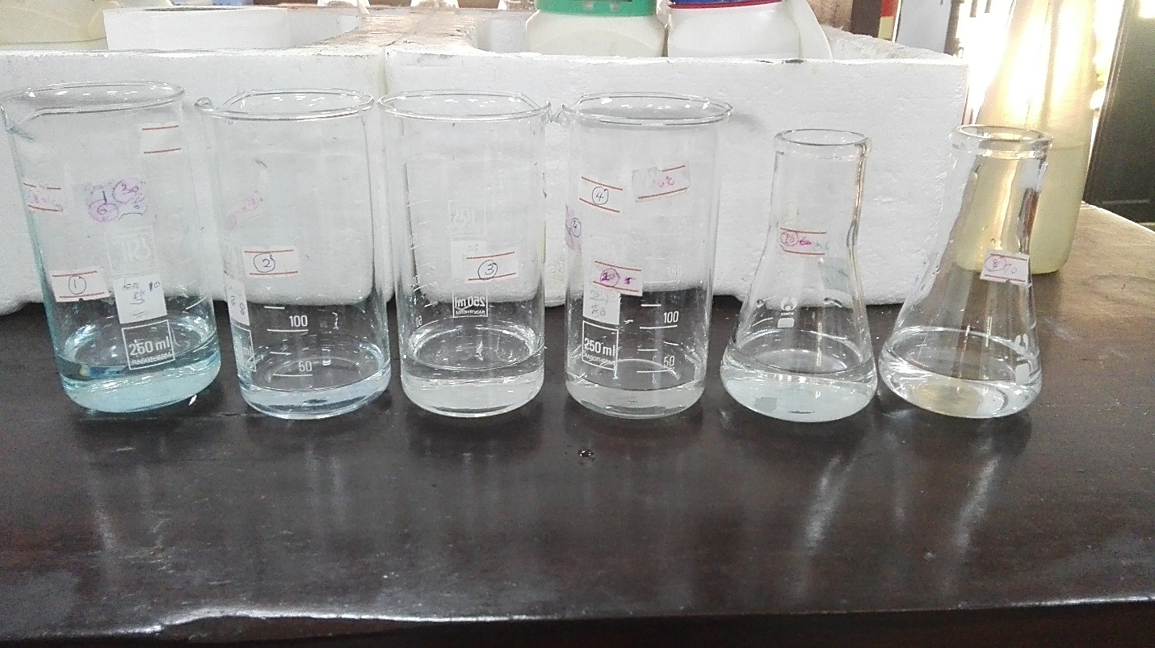

**Figure 3.16**. Equilibrium methylene blue solutions at each cycle (from left to right; cycle 01 to cycle 06

## Adsorption isotherm modelling

In this study, the Langmuir and Freundlich isotherm models were used to define the equilibrium data to assess the adsorption capacity of tire pyrolytic char, demineralized tire char, activated tire char and commercial carbon black for the removal of methylene blue dye from aqueous solution

### Langmuir isotherm model

According to the Langmuir adsorptio isotherm, sorption can proceed in a homogeneous manner, resulting in the formation of a monolayer. It can be used to determine the adsorbents' adsorption capabilities. The linear form of the Langmuir isotherm can be indicated as below.

$\frac{1}{qe}=\frac{1}{q_{max}K_{L}C_{e}}+\frac{1}{q_{max}}$

When plotting 1/ $q_{e}$ versus 1/ $C_{e}$, a straight line with a slope of $\frac{1}{K_{L}q_{max}}$ and an intercept of 1/ $q_{max}$ must be formed

Where,

$q_{max}=Maximum adsorption capacity\left(\frac{mg}{g}\right)$

$C_{e}$ = Equilibrium dye concentration (mg/L)

$$q_{e}=Amount of dye adsorbed(\frac{mg}{g})$$

${ K}_{L}$ = Langmuir constant/separation factor (L/mg)

The value of $K_{L}$ represent the following adsorption situations68

1 (Unfavorable adsorption)

${ K}_{L}$ $=$ 1 (Linear adsorption)

${ 0< K}_{L}<$ 1 (Favorable adsorption)

${ K}_{L}=$ 0 (Irreversible adsorption)

### Freundlich isotherm model

Freundlich adsorption isotherm can be used to define a non-ideal multilayer sorption on heterogeneous surfaces. The linear form of the Freundlich isotherm can be denoted as below.

log ${ q}_{e}=\frac{1}{n}$ log ${ C}_{e}+log{ K}_{F}$

Where,

(1/n) = heterogeneity factor

${ K}_{F}$ = Freundlich constant

${ C}_{e}$ = Equilibrium dye concentration (mg/L)

$q_{e}=Amount of dye adsorbed(\frac{mg}{g})$

The importance of the n value for methylene blue dye adsorption onto adsorbents can be is as follows94

n=1 (Linear adsorption)

n $<1(Adsorption is a chemical process)$

n $>1(Adsorption is a physical process)$

Table 3.22 represents the isotherm data for the linear plots for 1/ $q_{e}$ against 1/ $C_{e}$ and log $q_{e}$ versus log $C_{e}$ for methylene blue adsorption onto tire pyrolytic char at each adsorbent dosage.

**Table 3.22.** Average data for the adsorption isotherms of tire pyrolytic char

|  |  |  |  |  |  |  |
| --- | --- | --- | --- | --- | --- | --- |
| Adsorbent dosage per 50 mL of methylene blue solutions  (W $±$ 0.0001) | Equilibrium concentration  ($C_{e}$)/mg $L^{-1}$ | Amount of dye adsorbed ( $q_{e})$/mg $g^{-1}$ | 1/ $C_{e}$ | 1/ $q_{e}$ | log $C_{e}$ | log $q_{e}$ |
| 0.0050 | 3.44 | 65.56 | 0.29 | 0.02 | 0.53 | 1.81 |
| 0.0501 | 3.34 | 6.65 | 0.29 | 0.15 | 0.52 | 0.82 |
| 0.1000 | 2.93 | 3.53 | 0.34 | 0.28 | 0.46 | 0.54 |
| 0.2000 | 1.92 | 2.01 | 0.51 | 0.49 | 0.28 | 0.31 |
| 0.3000 | 1.06 | 1.48 | 0.94 | 0.67 | 0.03 | 0.17 |
| 0.4001 | 0.48 | 1.18 | 2.07 | 0.84 | -0.31 | 0.08 |
| 0.5002 | 0.35 | 0.96 | 2.80 | 1.03 | -0.44 | -0.01 |
| 0.6000 | 0.19 | 0.81 | 5.12 | 1.22 | -0.71 | -0.08 |
| 0.7001 | 0.18 | 0.70 | 5.39 | 1.42 | -0.73 | -0.15 |
| 0.8000 | 0.13 | 0.61 | 7.32 | 1.62 | -0.86 | -0.21 |
| 0.9001 | 0.08 | 0.55 | 12.05 | 1.81 | -1.08 | -0.25 |
| 1.0000 | 0.08 | 0.49 | 12.05 | 2.02 | -1.08 | -0.30 |

The Langmuir isotherm linear plot for the methylene blue adsorption onto tire pyrolytic char is given in the Figure 3.17.

**Figure 3.17.** The Langmuir isotherm model for the adsorption of methylene blue on tire pyrolytic char

The Freundlich isotherm linear plot for the methylene blue adsorption onto tire pyrolytic char is given in Figure 3.18.

**Figure 3.18**. Freundlich isotherm model for the adsorption of methylene blue on tire pyrolysis char

The Table 3.23 represents the isotherm data for the linear plots for 1/ $q_{e}$ against 1/ $C_{e}$ and log $q_{e}$ versus log $C_{e}$ for methylene blue adsorption onto demineralized tire char at each adsorbent dosage.

**Table 3.23**. Average data for the adsorption isotherms of demineralized tire char

|  |  |  |  |  |  |  |
| --- | --- | --- | --- | --- | --- | --- |
| Adsorbent dosage per 50 mL of methylene blue solutions(W $±$ 0.0001) | Equilibrium concentration($C_{e}$)/mg $L^{-1}$ | Amount of dye adsorbed ( $q_{e})$/mg $g^{-1}$ | 1/ $C_{e}$ | 1/ $q_{e}$ | log $C_{e}$ | log $q_{e}$ |
| 0.0050 | 9.12 | 43.51 | 0.10 | 0.02 | 0.96 | 1.63 |
| 0.0500 | 4.81 | 6.07 | 0.20 | 0.16 | 0.68 | 0.78 |
| 0.1000 | 3.19 | 3.36 | 0.31 | 0.29 | 0.50 | 0.52 |
| 0.2001 | 1.68 | 1.83 | 0.59 | 0.54 | 0.22 | 0.26 |
| 0.3001 | 0.40 | 1.30 | 2.46 | 0.76 | -0.39 | 0.12 |
| 0.4000 | 0.34 | 0.98 | 2.88 | 1.01 | -0.46 | -0.01 |
| 0.5002 | 0.31 | 0.78 | 3.15 | 1.27 | -0.49 | -0.10 |
| 0.6000 | 0.29 | 0.65 | 3.41 | 1.52 | -0.53 | -0.18 |
| 0.7001 | 0.28 | 0.56 | 3.47 | 1.77 | -0.54 | -0.25 |
| 0.8000 | 0.27 | 0.49 | 3.66 | 2.02 | -0.56 | -0.31 |
| 0.9001 | 0.21 | 0.43 | 4.65 | 2.27 | -0.66 | -0.35 |
| 1.0000 | 0.20 | 0.39 | 5.00 | 2.52 | -0.69 | -0.40 |

The Langmuir isotherm linear plot for the methylene blue adsorption onto demineralized tire char is given in the Figure 3.19.

**Figure 3.19**. Langmuir adsorption model for the removal of methylene blue dye on demineralized tire char

The Freundlich isotherm linear plot for the methylene blue adsorption onto demineralized tire char is given in Figure 3.20.

**Figure 3.20**. Freundlich isotherm model for the removal of methylene blue dye on demineralized tire char

Table 3.24 represents the isotherm data for the linear plots for 1/ $q_{e}$ against 1/ $C_{e}$ and log $q_{e}$ versus log $C_{e}$ for methylene blue adsorption onto activated tire char at each adsorbent dosage

**Table 3.24**. Average data for the adsorption isotherms of activated tire char

|  |  |  |  |  |  |  |
| --- | --- | --- | --- | --- | --- | --- |
| Adsorbent dosage per 50 mL of methylene blue solutions(W $±$ 0.0001) | Equilibrium concentration($C_{e}$)/mg $L^{-1}$ | Amount of dye adsorbed ( $q_{e})$/mg $g^{-1}$ | 1/ $C_{e}$ | 1/ $q_{e}$ | log $C_{e}$ | log $q_{e}$ |
| 0.0050 | 15.74 | 342.53 | 0.06 | 0.01 | 1.19 | 2.53 |
| 0.0500 | 12.74 | 37.25 | 0.07 | 0.03 | 1.10 | 1.57 |
| 0.1001 | 2.57 | 23.71 | 0.38 | 0.04 | 0.41 | 1.37 |
| 0.2000 | 0.19 | 12.45 | 5.25 | 0.08 | -0.72 | 1.09 |
| 0.3000 | 0.15 | 8.30 | 6.40 | 0.12 | -0.80 | 0.91 |
| 0.4001 | 0.14 | 6.23 | 7.06 | 0.16 | -0.84 | 0.79 |
| 0.5000 | 0.10 | 4.98 | 9.31 | 0.20 | -0.96 | 0.69 |
| 0.6000 | 0.07 | 4.16 | 13.66 | 0.24 | -1.13 | 0.61 |
| 0.7001 | 0.07 | 3.56 | 13.66 | 0.28 | -1.13 | 0.55 |
| 0.8000 | 0.09 | 3.11 | 10.78 | 0.32 | -1.03 | 0.49 |
| 0.9000 | 0.07 | 2.77 | 14.64 | 0.36 | -1.16 | 0.44 |
| 1.0000 | 0.058 | 2.49 | 17.08 | 0.40 | -1.23 | 0.39 |

The Langmuir isotherm linear plot for the methylene blue adsorption onto activated tire char is given in the Figure 3.21.

**Figure 3.21**. Langmuir adsorption model for the removal of methylene blue on activated tire char.

The Freundlich isotherm linear plot for the methylene blue adsorption onto activated tire

char is given in Figure 3.22.

**Figure 3.22**. Freundlich adsorption model for the removal of methylene blue on activated tire char

The Table 3.25 represents the isotherm data for the linear plots for 1/ $q_{e}$ against 1/ $C_{e}$ and log $q_{e}$ versus log $C_{e}$ for methylene blue adsorption onto commercial carbon black at each adsorbent dosage

**Table 3.25**. Average data for the adsorption isotherms of commercial carbon black

|  |  |  |  |  |  |  |
| --- | --- | --- | --- | --- | --- | --- |
| Adsorbent dosage per 50 mL of methylene blue solutions(W $±$ 0.0001) | Equilibrium concentration($C_{e}$)/mg $L^{-1}$ | Amount of dye adsorbed ( $q_{e})$/mg $g^{-1}$ | 1/ $C_{e}$ | 1/ $q_{e}$ | log $C_{e}$ | log $q_{e}$ |
| 0.0050 | 15.97 | 340.29 | 0.06 | 0.01 | 1.20 | 2.53 |
| 0.0500 | 15.76 | 3.42 | 0.06 | 0.29 | 1.19 | 0.53 |
| 0.1001 | 15.14 | 17.42 | 0.07 | 0.05 | 1.18 | 1.24 |
| 0.2001 | 10.56 | 9.85 | 0.09 | 0.10 | 1.02 | 0.99 |
| 0.3000 | 5.33 | 7.44 | 0.18 | 0.13 | 0.72 | 0.87 |
| 0.4002 | 3.71 | 5.78 | 0.26 | 0.17 | 0.57 | 0.76 |
| 0.5000 | 1.80 | 4.81 | 0.55 | 0.21 | 0.25 | 0.68 |
| 0.6001 | 1.15 | 4.07 | 0.86 | 0.2 | 0.06 | 0.60 |
| 0.7000 | 0.52 | 3.53 | 1.89 | 0.28 | -0.28 | 0.54 |
| 0.8001 | 0.32 | 3.10 | 3.05 | 0.32 | -0.48 | 0.49 |
| 0.9000 | 0.31 | 2.76 | 3.15 | 0.36 | -0.49 | 0.44 |
| 1.0002 | 0.31 | 2.48 | 3.20 | 0.40 | -0.50 | 0.39 |

The Langmuir isotherm linear plot for the methylene blue adsorption onto commercial carbon black is given in the Figure 3.23.

**Figure 3.23.** Langmuir adsorption model for the removal of methylene blue on commercial carbon black.

The Freundlich isotherm linear plot for the methylene blue adsorption onto commercial

carbon black is given in Figure 3.24.

**Figure 3.24**. Freundlich adsorption model for the removal of methylene blue on commercial carbon black

### The Langmuir and Freundlich isotherm constants and determination coefficients ( $R^{2})$ for methylene blue adsorption on adsorbents.

Table 3.26 lists the values of the isotherm constants as well as the determination coefficients ($R^{2})$ for tire pyrolytic char, demineralized tire char, activated tire char and commercial carbon black.

**Table 3.26.** The Langmuir and Freundlich isotherm constants for methylene blue adsorption on tire pyrolytic char

|  |  |  |  |  |  |  |
| --- | --- | --- | --- | --- | --- | --- |
| Type of adsorbent | Langmuir isotherm model | | | Freundlich isotherm model | | |
| $$R^{2}$$ | $q_{max}$ (mg/g) | $K_{L}$ (L/mg) | $$R^{2}$$ | n | $$K_{F}$$ |
| Tire pyrolytic char | 0.9345 | 1.61 | 5.38 | 0.9868 | 2.33 | 1.52 |
| Demineralized tire char | 0.9280 | 46.51 | 0.05 | 0.8969 | 1.04 | 2.00 |
| Activated tire char | 0.9221 | 133.33 | 0.34 | 0.8619 | 1.54 | 19.69 |
| Commercial carbon black(N330) | 0.9093 | 7.10 | 1.94 | 0.9725 | 2.92 | 4.08 |

When the values of ( $R^{2})$ were examined, the Langmuir model best fit the adsorption data for demineralized tire char and activated tire char, whereas the Freundlich isotherm model best fit the adsorption data for tire pyrolytic char and commercial carbon black.

It is clear that the active sites on the surface of demineralized tire char and activated tire char are distributed uniformly94. It implies that adsorption which is occurred on demineralized tire char and activated tire char is caused by the transfer or sharing of electrons between the adsorbent and the adsorbate (chemisorption), rather than by attractive forces between the sorbent and adsorbate molecules (physisorption)95. The separation factor ($K_{L}$) of demineralized tire char and activated tire char is 0.05 and 0.34 respectively which indicated that the adsorption is a favorable process while the adsorption of methylene blue dye on tire pyrolytic char and commercial carbon black indicates an unfavorable process ($R_{L }>1$). Furthermore, the n values obtained for the all four adsorbents was between 1 and 10 which represents that the adsorption of methylene blue dye onto these adsorbents is a physical process. The maximum adsorption capacities of several adsorbents on the adsorption of methylene blue dye is given in table 3.27.

**Table 3.27**. Adsorbent capacities of different adsorbents for the removal of methylene blue

|  |  |  |
| --- | --- | --- |
| Adsorbent | $$q_{max}(\frac{mg}{g})$$ | Source |
| Tea waste | 86.16 | 96 |
| Tanned solid wastes | 84 | 97 |
| Brazil nut shell | 7.81 | 98 |
| Pineapple stem waste | 119.05 | 99 |
| Coconut bunch waste | 70.92 | 100 |
| Banana peel | 15.9 | 101 |
| Activated tires (850 ) | 1.3 | 102 |
| Glass fiber | 2.24 | 103 |
| Fly ash | 5.57 | 104 |
| Bone charcoal | 5 | 68 |
| **Tire pyrolytic char** | **1.61** | **Present study** |
| **Demineralized tire char** | **46.51** | **Present study** |
| **Activated tire char** | **133.33** | **Present study** |
| **Commercial carbon black** | **7.10** | **Present study** |

According to the present study, maximum adsorption capacities ($q_{max}$) of tire pyrolytic char, demineralized tire char, activated tire char and commercial carbon black was 1.61 mg ${ g}^{-1}$, 46.51 mg $g^{-1}$, 133.33 mg $g^{-1}$ and 7.10 mg $g^{-1}$ respectively. The ${ q}_{max}$ values for activated tire char for the removal of methylene blue dye is significantly higher than the adsorbents given in Table 3.27. As a result, it is important that activated tire char has a high potential for methylene blue dye adsorption from aqueous solutions.

**CHAPTER 04**

# Conclusions, suggestions, and future perspectives

In this study, tire pyrolytic char was purified using acid/alkali demineralization and modified into activated tire char by impregnating KOH onto demineralized tire char with 4:1 ratio. According to the proximate analysis, the ash content of tire pyrolytic char was found to be 36.59%. Upon demineralization, the ash content has been decreased to 6.98%. Carbon content of the adsorbents was increased in the order: tire pyrolytic char (65.03 wt. %)< demineralized char (74.15 wt. %)< activated tire char (77.30 wt. %). SEM analysis revealed that demineralized tire char and activated tire char were highly porous than tire pyrolytic char which demonstrates a greater potential for dye removal by adsorbing into pores. The removal of methylene blue dye by adsorbents is dependent on process parameters such as solution pH, adsorbent dosage, contact time, and temperature, according to batch adsorption studies. The optimum conditions for maximum removal of methylene blue dye by tire pyrolytic char were pH 6.0, contact time of 20 minutes, adsorbent dose of 0.4 g per 50 mL of 10 ppm of methylene blue solution. and temperature of 60 $℃$ whereas the pH of 6.0, contact time of 20 minutes, adsorbent dose of 0.2 g per 50 mL of 20 ppm of methylene blue solution, and temperature of 40°C were found to be optimal for maximum removal of methylene blue dye by demineralized tire char. The best conditions for removing methylene blue dye from activated tire char were pH 10.0, contact time of 25 minutes, adsorbent dose of 0.1 g per 50 mL of 50 ppm methylene blue solution, and temperature of 70°C while pH 10.0, contact time of 20 minutes, adsorbent dose of 0.4 g per 50 mL of 50 ppm of methylene blue solution, and temperature of 60°C were found to be the optimum conditions for maximum dye removal by commercial carbon black.

The Langmuir and Freundlich adsorption isotherm models were used to fit the adsorption equilibrium data from the batch adsorption investigations, and the results fit the Freundlich model for tire pyrolytic char and commercial carbon black better than the Langmuir model, demonstrating multilayer adsorption of methylene blue dye onto these adsorbents. The equilibrium adsorption data fit the Langmuir model for demineralized tire char and activated tire char better than the Freundlich model, indicating monolayer adsorption of methylene blue dye. According to the adsorption isotherm data, maximum adsorption capacities of tire pyrolytic char, demineralized tire char activated tire char and commercial carbon black were 1.61 mg/g, 46.51mg/g, 133.33mg/g, and 7.10 mg/g respectively.

According to desorption studies, the predominant benefit of demineralized tire char was its reusability. Demineralized tire char facilitates $\sim$ 99% dye removal over the all six cycles indicating its huge potential for dye removal at adsorbent dosage of 0.2 g per 50 mL of 50 ppm methylene blue solution. According to the present study, it was revealed that demineralized tire char and activated tire char can be used as excellent adsorbent precursors for dye removal from aqueous solutions compared to commercially available carbon black.

However, this study attempted to focus on the removal of methylene blue dye from aqueous solutions and the development of low-cost adsorbents using tire pyrolytic char. It is important to note that the maximum adsorption capacities investigated in this study provide some insight into the effectiveness of adsorbents for methylene blue removal and are primarily dependent on experimental conditions.

Suggestions and future perspectives

The use of waste materials as low-cost adsorbents for removing various dyes from water and wastewater has many appealing features, particularly their contribution to waste disposal cost reduction, which contributes to environmental protection. Although the amount of reported literature on the use of low-cost adsorbents in removal of dyes from industrial water is rapidly increasing, there are still several gaps that must be filled. Some of the major issues are summarized below:

* It is necessary to optimize the conditions for the production of low-cost adsorbents after surface modification for increased dye uptake.
* The cost factor should not be overlooked. The process would be more economical and efficient if the adsorbents had a lower production cost and a higher removal efficiency.
* To recover the adsorbate as well as the adsorbent, detailed regeneration studies must be carried out. It will improve the process's economic feasibility.
* It is also suggested that the research not be limited to lab scale batch studies, but that pilot-plant studies utilizing these adsorbents be conducted to determine their commercial feasibility.
* The advancement of the adsorption process using waste tire pyrolytic char essentially necessitates more research into testing these materials with real industrial effluents.

If such adsorbents with all of the aforementioned characteristics can be developed, they may offer great benefits over currently available expensive commercially activated carbons while also contributing to an overall pollution control and waste minimization strategy.

**REFERENCES**

(1) Portofino, S.; Casu, S.; Iovane, P.; Russo, A.; Martino, M.; Donatelli, A.; Galvagno, S. Optimizing H2 Production from Waste Tires via Combined Steam Gasification and Catalytic Reforming. *Energy and Fuels* **2011**, *25* (5), 2232–2241. https://doi.org/10.1021/ef200072c.

(2) Acosta, R.; Fierro, V.; Martinez de Yuso, A.; Nabarlatz, D.; Celzard, A. Tetracycline Adsorption onto Activated Carbons Produced by KOH Activation of Tyre Pyrolysis Char. *Chemosphere* **2016**, *149*, 168–176. https://doi.org/10.1016/j.chemosphere.2016.01.093.

(3) Kuśmierek, K.; Świątkowski, A.; Kotkowski, T.; Cherbański, R.; Molga, E. Adsorption Properties of Activated Tire Pyrolysis Chars for Phenol and Chlorophenols. *Chem. Eng. Technol.* **2020**. https://doi.org/10.1002/ceat.201900574.

(4) Manchón-Vizuete, E.; MacÍas-García, A.; Nadal Gisbert, A.; Fernández-González, C.; Gómez-Serrano, V. Adsorption of Mercury by Carbonaceous Adsorbents Prepared from Rubber of Tyre Wastes. *J. Hazard. Mater.* **2005**. https://doi.org/10.1016/j.jhazmat.2004.12.028.

(5) Chan, O. S.; Cheung, W. H.; McKay, G. Preparation and Characterisation of Demineralised Tyre Derived Activated Carbon. *Carbon N. Y.* **2011**, *49* (14), 4674–4687. https://doi.org/10.1016/j.carbon.2011.06.065.

(6) Chan, O. S.; Cheung, W. H.; McKay, G. Single and Multicomponent Acid Dye Adsorption Equilibrium Studies on Tyre Demineralised Activated Carbon. *Chem. Eng. J.* **2012**, *191*, 162–170. https://doi.org/10.1016/j.cej.2012.02.089.

(7) Chan, O. S.; Cheung, W. H.; Ckay, G. M. Equilibrium and Kinetics of Lead Adsorption onto Tyre Char. *HKIE Trans. Hong Kong Inst. Eng.* **2012**, *19* (4), 20–28. https://doi.org/10.1080/1023697X.2012.10669001.

(8) Ramos, G.; Alguacil, F. J.; López, F. A. The Recycling of End-of-Life Tyres. Technological Review(̇). *Revista de Metalurgia (Madrid)*. 2011. https://doi.org/10.3989/revmetalm.1052.

(9) Rowhani, A.; Rainey, T. J. Scrap Tyre Management Pathways and Their Use as a Fuel - A Review. *Energies*. 2016. https://doi.org/10.3390/en9110888.

(10) Makrigianni, V.; Giannakas, A.; Hela, D.; Papadaki, M.; Konstantinou, I. Adsorption of Methylene Blue Dye by Pyrolytic Tire Char in Fixed-Bed Column. *Desalin. Water Treat.* **2017**. https://doi.org/10.5004/dwt.2017.20340.

(11) Zhang, J.; Jones, I.; Zhu, M.; Zhang, Z.; Preciado-Hernandez, J.; Zhang, D. Pore Development During CO2 and Steam Activation of a Spent Tyre Pyrolysis Char. *Waste and Biomass Valorization* **2020**, No. 0123456789. https://doi.org/10.1007/s12649-020-01165-4.

(12) Gauthier-Maradei, P.; Cely Valderrama, Y.; Nabarlatz, D. Mathematical Model of Scrap Tire Rubber Pyrolysis in a Non-Isothermal Fixed Bed Reactor: Definition of a Chemical Mechanism and Determination of Kinetic Parameters. *Waste and Biomass Valorization* **2019**. https://doi.org/10.1007/s12649-017-0079-7.

(13) Wang, Z. Bin; Tian, Y. J.; Wang, X. K. Adsorption Performance to Methylene Blue by Non-Activated Tire-Based Pyrolytic Char. In *Applied Mechanics and Materials*; 2014. https://doi.org/10.4028/www.scientific.net/AMM.508.35.

(14) Iraola-Arregui, I.; Van Der Gryp, P.; Görgens, J. F. A Review on the Demineralisation of Pre- and Post-Pyrolysis Biomass and Tyre Wastes. *Waste Manag.* **2018**, *79*, 667–688. https://doi.org/10.1016/j.wasman.2018.08.034.

(15) Alsaleh, A.; Sattler, M. L. Waste Tire Pyrolysis: Influential Parameters and Product Properties. *Current Sustainable/Renewable Energy Reports*. 2014. https://doi.org/10.1007/s40518-014-0019-0.

(16) Chan, O. S.; Cheung, W. H.; Ckay, G. M. Equilibrium and Kinetics of Lead Adsorption onto Tyre Char. *HKIE Trans. Hong Kong Inst. Eng.* **2012**. https://doi.org/10.1080/1023697X.2012.10669001.

(17) Antoniou, N.; Stavropoulos, G.; Zabaniotou, A. Activation of End of Life Tyres Pyrolytic Char for Enhancing Viability of Pyrolysis - Critical Review, Analysis and Recommendations for a Hybrid Dual System. *Renewable and Sustainable Energy Reviews*. 2014. https://doi.org/10.1016/j.rser.2014.07.143.

(18) Al-Rahbi, A. S.; Williams, P. T. Hydrogen-Rich Syngas Production and Tar Removal from Biomass Gasification Using Sacrificial Tyre Pyrolysis Char. *Appl. Energy* **2017**. https://doi.org/10.1016/j.apenergy.2016.12.099.

(19) Wang, M.; Zhang, L.; Li, A.; Irfan, M.; Du, Y.; Di, W. Comparative Pyrolysis Behaviors of Tire Tread and Side Wall from Waste Tire and Characterization of the Resulting Chars. *J. Environ. Manage.* **2019**, *232* (October 2018), 364–371. https://doi.org/10.1016/j.jenvman.2018.10.091.

(20) Liu, X.; Wang, J.; Gheni, A.; ElGawady, M. A. Reduced Zinc Leaching from Scrap Tire during Pavement Applications. *Waste Manag.* **2018**. https://doi.org/10.1016/j.wasman.2018.09.045.

(21) Chaala, A.; Darmstadt, H.; Roy, C. Acid-Base Method for the Demineralization of Pyrolytic Carbon Black. *Fuel Process. Technol.* **1996**, *46* (1), 1–15. https://doi.org/10.1016/0378-3820(95)00044-5.

(22) Rhodes, E. P.; Ren, Z.; Mays, D. C. Zinc Leaching from Tire Crumb Rubber. *Environ. Sci. Technol.* **2012**, *46* (23), 12856–12863. https://doi.org/10.1021/es3024379.

(23) Yadav, S.; Yadav, S. Investigations of Metal Leaching from Mobile Phone Parts Using TCLP and WET Methods. *J. Environ. Manage.* **2014**, *144*, 101–107. https://doi.org/10.1016/j.jenvman.2014.05.022.

(24) Torretta, V.; Rada, E. C.; Ragazzi, M.; Trulli, E.; Istrate, I. A.; Cioca, L. I. Treatment and Disposal of Tyres: Two EU Approaches. A Review. *Waste Manag.* **2015**, *45*, 152–160. https://doi.org/10.1016/j.wasman.2015.04.018.

(25) Karger-Kocsis, J.; Mészáros, L.; Bárány, T. *Ground Tyre Rubber (GTR) in Thermoplastics, Thermosets, and Rubbers*; 2013; Vol. 48. https://doi.org/10.1007/s10853-012-6564-2.

(26) Yu, C.; Thy, P.; Wang, L.; Anderson, S. N.; Vandergheynst, J. S.; Upadhyaya, S. K.; Jenkins, B. M. Influence of Leaching Pretreatment on Fuel Properties of Biomass. *Fuel Process. Technol.* **2014**, *128*, 43–53. https://doi.org/10.1016/j.fuproc.2014.06.030.

(27) Nelson, S. M.; Mueller, G.; Hemphill, D. C. Identification of Tire Leachate Toxicants and a Risk Assessment of Water Quality Effects Using Tire Reefs in Canals. *Bull. Environ. Contam. Toxicol.* **1994**, *52* (4), 574–581. https://doi.org/10.1007/BF00194146.

(28) Pan, Z.; Zhao, C. Y. Dehydration/Hydration of MgO/H2O Chemical Thermal Storage System. *Energy* **2015**, *82*, 611–618. https://doi.org/10.1016/j.energy.2015.01.070.

(29) Meshram, P.; Purohit, B. K.; Sinha, M. K.; Sahu, S. K.; Pandey, B. D. Demineralization of Low Grade Coal - A Review. *Renew. Sustain. Energy Rev.* **2015**, *41*, 745–761. https://doi.org/10.1016/j.rser.2014.08.072.

(30) Gualtieri, M.; Andrioletti, M.; Vismara, C.; Milani, M.; Camatini, M. Toxicity of Tire Debris Leachates. *Environ. Int.* **2005**, *31* (5), 723–730. https://doi.org/10.1016/j.envint.2005.02.001.

(31) Tian, X.; Yin, X.; gong, Y.; Wu, Y.; Tan, Z.; Xu, P. Characterization, Recovery Potentiality, and Evaluation on Recycling Major Metals from Waste Cathode-Ray Tube Phosphor Powder by Using Sulphuric Acid Leaching. *J. Clean. Prod.* **2016**, *135*, 1210–1217. https://doi.org/10.1016/j.jclepro.2016.07.044.

(32) Mukherjee, S.; Borthakur, P. C. Effect of Leaching High Sulphur Subbituminous Coal by Potassium Hydroxide and Acid on Removal of Mineral Matter and Sulphur. *Fuel* **2003**, *82* (7), 783–788. https://doi.org/10.1016/S0016-2361(02)00360-5.

(33) Mui, E. L. K.; Cheung, W. H.; Valix, M.; McKay, G. Dye Adsorption onto Activated Carbons from Tyre Rubber Waste Using Surface Coverage Analysis. *J. Colloid Interface Sci.* **2010**. https://doi.org/10.1016/j.jcis.2010.03.061.

(34) Manocha, S.; Prasad, G. R.; Joshi, P.; Zala, R. S.; Gokhale, S. S.; Manocha, L. M. Preparation and Characterization of Activated Carbon from Demineralized Tyre Char. *AIP Conf. Proc.* **2013**, *1538*, 109–112. https://doi.org/10.1063/1.4810039.

(35) Gupta, V. K.; Ganjali, M. R.; Nayak, A.; Bhushan, B.; Agarwal, S. Enhanced Heavy Metals Removal and Recovery by Mesoporous Adsorbent Prepared from Waste Rubber Tire. *Chem. Eng. J.* **2012**, *197*, 330–342. https://doi.org/10.1016/j.cej.2012.04.104.

(36) Amran, F.; Zaini, M. A. A. Effects of Chemical Activating Agents on Physical Properties of Activated Carbons – A Commentary. *Water Pract. Technol.* **2020**, *15* (4), 854–876. https://doi.org/10.2166/wpt.2020.094.

(37) Lin, J. H.; Wang, S. B. An Effective Route to Transform Scrap Tire Carbons into Highly-Pure Activated Carbons with a High Adsorption Capacity of Ethylene Blue through Thermal and Chemical Treatments. *Environ. Technol. Innov.* **2017**, *8* (March), 17–27. https://doi.org/10.1016/j.eti.2017.03.004.

(38) Loloie, Z.; Mozaffarian, M.; Soleimani, M.; Asassian, N. Carbonization and CO2 Activation of Scrap Tires: Optimization of Specific Surface Area by the Taguchi Method. *Korean J. Chem. Eng.* **2017**, *34* (2), 366–375. https://doi.org/10.1007/s11814-016-0266-4.

(39) Betancur, M.; Martínez, J. D.; Murillo, R. Production of Activated Carbon by Waste Tire Thermochemical Degradation with CO2. *J. Hazard. Mater.* **2009**, *168* (2–3), 882–887. https://doi.org/10.1016/j.jhazmat.2009.02.167.

(40) Hsu, L. Y.; Teng, H. Influence of Different Chemical Reagents on the Preparation of Activated Carbons from Bituminous Coal. *Fuel Process. Technol.* **2000**, *64* (1), 155–166. https://doi.org/10.1016/S0378-3820(00)00071-0.

(41) Mui, E. L. K.; Cheung, W. H.; Valix, M.; McKay, G. Mesoporous Activated Carbon from Waste Tyre Rubber for Dye Removal from Effluents. *Microporous Mesoporous Mater.* **2010**, *130* (1–3), 287–294. https://doi.org/10.1016/j.micromeso.2009.11.022.

(42) Nahil, M. A.; Williams, P. T. Characterisation of Activated Carbons with High Surface Area and Variable Porosity Produced from Agricultural Cotton Waste by Chemical Activation and Co-Activation. *Waste and Biomass Valorization* **2012**, *3* (2), 117–130. https://doi.org/10.1007/s12649-012-9109-7.

(43) Choi, G. G.; Jung, S. H.; Oh, S. J.; Kim, J. S. Total Utilization of Waste Tire Rubber through Pyrolysis to Obtain Oils and CO2 Activation of Pyrolysis Char. *Fuel Process. Technol.* **2014**, *123*, 57–64. https://doi.org/10.1016/j.fuproc.2014.02.007.

(44) Wang, J.; Liu, T. L.; Huang, Q. X.; Ma, Z. Y.; Chi, Y.; Yan, J. H. Production and Characterization of High Quality Activated Carbon from Oily Sludge. *Fuel Process. Technol.* **2017**, *162*, 13–19. https://doi.org/10.1016/j.fuproc.2017.03.017.

(45) Tazibet, S.; Velasco, L. F.; Lodewyckx, P.; Abou M’Hamed, D.; Boucheffa, Y. Study of the Carbonization Temperature for a Chemically Activated Carbon: Influence on the Textural and Structural Characteristics and Surface Functionalities. *J. Porous Mater.* **2018**, *25* (2), 329–340. https://doi.org/10.1007/s10934-017-0444-8.

(46) Kucinska, A.; Golembiewski, R.; Lukaszewicz, J. P. Synthesis of N-Rich Activated Carbons from Chitosan by Chemical Activation. *Sci. Adv. Mater.* **2014**, *6* (2), 290–297. https://doi.org/10.1166/sam.2014.1714.

(47) Zhang, H.; Yan, Y.; Yang, L. Preparation of Activated Carbons from Sawdust by Chemical Activation. *Adsorpt. Sci. Technol.* **2008**, *26* (7), 533–543. https://doi.org/10.1260/0263-6174.26.7.533.

(48) Boujibar, O.; Souikny, A.; Ghamouss, F.; Achak, O.; Dahbi, M.; Chafik, T. CO2 Capture Using N-Containing Nanoporous Activated Carbon Obtained from Argan Fruit Shells. *J. Environ. Chem. Eng.* **2018**, *6* (2), 1995–2002. https://doi.org/10.1016/j.jece.2018.03.005.

(49) Teng, H.; Lin, Y. C.; Hsu, L. Y. Production of Activated Carbons from Pyrolysis of Waste Tires Impregnated with Potassium Hydroxide. *J. Air Waste Manag. Assoc.* **2000**. https://doi.org/10.1080/10473289.2000.10464221.

(50) Yang, B.; Liu, Y.; Liang, Q.; Chen, M.; Ma, L.; Li, L.; Liu, Q.; Tu, W.; Lan, D.; Chen, Y. Evaluation of Activated Carbon Synthesized by One-Stage and Two-Stage Co-Pyrolysis from Sludge and Coconut Shell. *Ecotoxicol. Environ. Saf.* **2019**, *170* (November 2018), 722–731. https://doi.org/10.1016/j.ecoenv.2018.11.130.

(51) Seo, S. W.; Choi, Y. J.; Kim, J. H.; Cho, J. H.; Lee, Y. S.; Im, J. S. Micropore-Structured Activated Carbon Prepared by Waste PET/Petroleum-Based Pitch. *Carbon Lett.* **2019**, *29* (4), 385–392. https://doi.org/10.1007/s42823-019-00028-w.

(52) Fu, Y.; Shen, Y.; Zhang, Z.; Ge, X.; Chen, M. Activated Bio-Chars Derived from Rice Husk via One- and Two-Step KOH-Catalyzed Pyrolysis for Phenol Adsorption. *Sci. Total Environ.* **2019**, *646*, 1567–1577. https://doi.org/10.1016/j.scitotenv.2018.07.423.

(53) Wu, H.; Chen, R.; Du, H.; Zhang, J.; Shi, L.; Qin, Y.; Yue, L.; Wang, J. Synthesis of Activated Carbon from Peanut Shell as Dye Adsorbents for Wastewater Treatment. *Adsorpt. Sci. Technol.* **2019**, *37* (1–2), 34–48. https://doi.org/10.1177/0263617418807856.

(54) Kang, S.; Jiang, S.; Peng, Z.; Lu, Y.; Guo, J.; Li, J.; Zeng, W.; Lin, X. Valorization of Humins by Phosphoric Acid Activation for Activated Carbon Production. *Biomass Convers. Biorefinery* **2018**, *8* (4), 889–897. https://doi.org/10.1007/s13399-018-0329-3.

(55) Baek, J.; Lee, H. M.; An, K. H.; Kim, B. J. Preparation and Characterization of Highly Mesoporous Activated Short Carbon Fibers from Kenaf Precursors. *Carbon Lett.* **2019**, *29* (4), 393–399. https://doi.org/10.1007/s42823-019-00042-y.

(56) Oliveira, G.; Calisto, V.; Santos, S. M.; Otero, M.; Esteves, V. I. Paper Pulp-Based Adsorbents for the Removal of Pharmaceuticals from Wastewater: A Novel Approach towards Diversification. *Sci. Total Environ.* **2018**, *631*–*632*, 1018–1028. https://doi.org/10.1016/j.scitotenv.2018.03.072.

(57) Garba, Z. N.; Rahim, A. A.; Bello, B. Z. *Optimization of Preparation Conditions for Activated Carbon from Brachystegia Eurycoma Seed Hulls: A New Precursor Using Central Composite Design*; Elsevier B.V., 2015; Vol. 3. https://doi.org/10.1016/j.jece.2015.10.017.

(58) Zhou, B.; Gao, Q.; Wang, H.; Duan, E.; Guo, B.; Zhu, N. Preparation, Characterization, and Phenol Adsorption of Activated Carbons from Oxytetracycline Bacterial Residue. *J. Air Waste Manag. Assoc.* **2012**, *62* (12), 1394–1402. https://doi.org/10.1080/10962247.2012.716013.

(59) Vunain, E.; Houndedjihou, D.; Monjerezi, M.; Muleja, A. A.; Kodom, B. T. Adsorption, Kinetics and Equilibrium Studies on Removal of Catechol and Resorcinol from Aqueous Solution Using Low-Cost Activated Carbon Prepared from Sunflower (Helianthus Annuus) Seed Hull Residues. *Water. Air. Soil Pollut.* **2018**, *229* (11). https://doi.org/10.1007/s11270-018-3993-9.

(60) Paredes-Laverde, M.; Salamanca, M.; Silva-Agredo, J.; Manrique-Losada, L.; Torres-Palma, R. A.; Vunain, E.; Houndedjihou, D.; Monjerezi, M.; Muleja, A. A.; Kodom, B. T. Adsorption, Kinetics and Equilibrium Studies on Removal of Catechol and Resorcinol from Aqueous Solution Using Low-Cost Activated Carbon Prepared from Sunflower (Helianthus Annuus) Seed Hull Residues. *Water. Air. Soil Pollut.* **2018**, *7* (5), 103318. https://doi.org/10.1016/j.jece.2019.103318.

(61) Hasanzadeh, V.; Rahmanian, O.; Heidari, M. Cefixime Adsorption onto Activated Carbon Prepared by Dry Thermochemical Activation of Date Fruit Residues. *Microchem. J.* **2020**, *152*, 104261. https://doi.org/10.1016/j.microc.2019.104261.

(62) Hui, T. S.; Zaini, M. A. A. Potassium Hydroxide Activation of Activated Carbon: A Commentary. *Carbon Lett.* **2015**, *16* (4), 275–280. https://doi.org/10.5714/CL.2015.16.4.275.

(63) Lillo-Ródenas, M. A.; Cazorla-Amorós, D.; Linares-Solano, A. Understanding Chemical Reactions between Carbons and NaOH and KOH: An Insight into the Chemical Activation Mechanism. *Carbon N. Y.* **2003**, *41* (2), 267–275. https://doi.org/10.1016/S0008-6223(02)00279-8.

(64) Bhatnagar, A.; Sillanpää, M. Utilization of Agro-Industrial and Municipal Waste Materials as Potential Adsorbents for Water Treatment-A Review. *Chemical Engineering Journal*. 2010. https://doi.org/10.1016/j.cej.2010.01.007.

(65) Kaya, N.; Yıldız, Z.; Ceylan, S. Preparation and Characterisation of Biochar from Hazelnut Shell and Its Adsorption Properties for Methylene Blue Dye. *J. Polytech.* **2018**. https://doi.org/10.2339/politeknik.386963.

(66) Amuda, O. S.; Olayiwola, A. O.; Alade, A. O.; Farombi, A. G.; Adebisi, S. A. Adsorption of Methylene Blue from Aqueous Solution Using Steam-Activated Carbon Produced from &lt;I&gt;Lantana Camara&lt;/I&gt; Stem. *J. Environ. Prot. (Irvine,. Calif).* **2014**. https://doi.org/10.4236/jep.2014.513129.

(67) Mohammed, M. a; Shitu, a; Ibrahim, a. Removal of Methylene Blue Using Low Cost Adsorbent : A Review. *Res. J. Chem. Sci.* **2014**.

(68) Ghanizadeh, G.; Asgari, G. Adsorption Kinetics and Isotherm of Methylene Blue and Its Removal from Aqueous Solution Using Bone Charcoal. *React. Kinet. Mech. Catal.* **2011**. https://doi.org/10.1007/s11144-010-0247-2.

(69) Tkaczyk, A.; Mitrowska, K.; Posyniak, A. Synthetic Organic Dyes as Contaminants of the Aquatic Environment and Their Implications for Ecosystems: A Review. *Science of the Total Environment*. 2020. https://doi.org/10.1016/j.scitotenv.2020.137222.

(70) Gupta, V. K.; Gupta, B.; Rastogi, A.; Agarwal, S.; Nayak, A. A Comparative Investigation on Adsorption Performances of Mesoporous Activated Carbon Prepared from Waste Rubber Tire and Activated Carbon for a Hazardous Azo Dye-Acid Blue 113. *J. Hazard. Mater.* **2011**. https://doi.org/10.1016/j.jhazmat.2010.11.091.

(71) Amode, J. O.; Santos, J. H.; Md. Alam, Z.; Mirza, A. H.; Mei, C. C. Adsorption of Methylene Blue from Aqueous Solution Using Untreated and Treated (Metroxylon Spp.) Waste Adsorbent: Equilibrium and Kinetics Studies. *Int. J. Ind. Chem.* **2016**. https://doi.org/10.1007/s40090-016-0085-9.

(72) Shi, B.; Li, G.; Wang, D.; Feng, C.; Tang, H. Removal of Direct Dyes by Coagulation: The Performance of Preformed Polymeric Aluminum Species. *J. Hazard. Mater.* **2007**. https://doi.org/10.1016/j.jhazmat.2006.09.076.

(73) Rahbar, M. S.; Alipour, E.; Sedighi, R. E. Color Removal from Industrial Wastewater with a Novel Coagulant Flocculant Formulation. *Int. J. Environ. Sci. Technol.* **2006**. https://doi.org/10.1007/BF03325910.

(74) Yue, Q. Y.; Gao, B. Y.; Wang, Y.; Zhang, H.; Sun, X.; Wang, S. G.; Gu, R. R. Synthesis of Polyamine Flocculants and Their Potential Use in Treating Dye Wastewater. *J. Hazard. Mater.* **2008**. https://doi.org/10.1016/j.jhazmat.2007.06.089.

(75) Mishra, A.; Bajpai, M. The Flocculation Performance of Tamarindus Mucilage in Relation to Removal of Vat and Direct Dyes. *Bioresour. Technol.* **2006**. https://doi.org/10.1016/j.biortech.2005.04.049.

(76) Fu, Y.; Viraraghavan, T. Fungal Decolorization of Dye Wastewaters: A Review. *Bioresour. Technol.* **2001**. https://doi.org/10.1016/S0960-8524(01)00028-1.

(77) Crini, G. Non-Conventional Low-Cost Adsorbents for Dye Removal: A Review. *Bioresource Technology*. 2006. https://doi.org/10.1016/j.biortech.2005.05.001.

(78) Jain, R.; Gupta, V. K.; Sikarwar, S. Adsorption and Desorption Studies on Hazardous Dye Naphthol Yellow S. *J. Hazard. Mater.* **2010**. https://doi.org/10.1016/j.jhazmat.2010.06.098.

(79) Sen, T. K.; Afroze, S.; Ang, H. M. Equilibrium, Kinetics and Mechanism of Removal of Methylene Blue from Aqueous Solution by Adsorption onto Pine Cone Biomass of Pinus Radiata. *Water. Air. Soil Pollut.* **2011**. https://doi.org/10.1007/s11270-010-0663-y.

(80) Nedu, M. E.; Tertis, M.; Cristea, C.; Georgescu, A. V. Comparative Study Regarding the Properties of Methylene Blue and Proflavine and Their Optimal Concentrations for in Vitro and in Vivo Applications. *Diagnostics* **2020**, *10* (4), 1–26. https://doi.org/10.3390/diagnostics10040223.

(81) Omorogie, M. O.; Babalola, J. O.; Unuabonah, E. I. Regeneration Strategies for Spent Solid Matrices Used in Adsorption of Organic Pollutants from Surface Water: A Critical Review. *Desalin. Water Treat.* **2016**, *57* (2), 518–544. https://doi.org/10.1080/19443994.2014.967726.

(82) Li, Y.; Wang, S.; Shen, Z.; Li, X.; Zhou, Q.; Sun, Y.; Wang, T.; Liu, Y.; Gao, Q. Gradient Adsorption of Methylene Blue and Crystal Violet onto Compound Microporous Silica from Aqueous Medium. *ACS Omega* **2020**. https://doi.org/10.1021/acsomega.0c04437.

(83) Harindra, T. N.; Hewage, J. S.; Ranaweera, A. S. Recycling Tire Wastes To Produce Carbon Black For.

(84) López, F. A.; Centeno, T. A.; Rodríguez, O.; Alguacil, F. J. Preparation and Characterization of Activated Carbon from the Char Produced in the Thermolysis of Granulated Scrap Tyres. *J. Air Waste Manag. Assoc.* **2013**, *63* (5), 534–544. https://doi.org/10.1080/10962247.2013.763870.

(85) Treeweranuwat, P.; Boonyoung, P.; Chareonpanich, M.; Nueangnoraj, K. Role of Nitrogen on the Porosity, Surface, and Electrochemical Characteristics of Activated Carbon. *ACS Omega* **2020**, *5* (4), 1911–1918. https://doi.org/10.1021/acsomega.9b03586.

(86) Jjagwe, J.; Olupot, P. W.; Menya, E.; Kalibbala, H. M. Synthesis and Application of Granular Activated Carbon from Biomass Waste Materials for Water Treatment: A Review. *J. Bioresour. Bioprod.* **2021**, No. February. https://doi.org/10.1016/j.jobab.2021.03.003.

(87) Nogueira; Matos; Bernardo; Pinto; Lapa; Surra; Fonseca. Char from Spent Tire Rubber: A Potential Adsorbent of Remazol Yellow Dye. *C — J. Carbon Res.* **2019**. https://doi.org/10.3390/c5040076.

(88) López, F. A.; Centeno, T. A.; Rodríguez, O.; Alguacil, F. J. Preparation and Characterization of Activated Carbon from the Char Produced in the Thermolysis of Granulated Scrap Tyres. *J. Air Waste Manag. Assoc.* **2013**. https://doi.org/10.1080/10962247.2013.763870.

(89) Rutto, H.; Seidigeng, T.; Malise, L. Adsorption of Lead Ions onto Chemically Activated Carbon from Waste Tire Char and Optimization of the Process Using Response Surface Methodology. *Arch. Environ. Prot.* **2019**. https://doi.org/10.24425/aep.2019.130245.

(90) Om Prakash, M.; Raghavendra, G.; Ojha, S.; Panchal, M. Characterization of Porous Activated Carbon Prepared from Arhar Stalks by Single Step Chemical Activation Method. *Mater. Today Proc.* **2020**, *39* (xxxx), 1476–1481. https://doi.org/10.1016/j.matpr.2020.05.370.

(91) Khezami, L.; Capart, R. Removal of Chromium(VI) from Aqueous Solution by Activated Carbons: Kinetic and Equilibrium Studies. *J. Hazard. Mater.* **2005**. https://doi.org/10.1016/j.jhazmat.2005.04.012.

(92) Abdul Ameer, A. M. Removal of Mixture of Phenolic Compounds from Aqueous Solution by Tire Char Adsorption. *IOP Conf. Ser. Mater. Sci. Eng.* **2019**, *518* (6). https://doi.org/10.1088/1757-899X/518/6/062011.

(93) Shabaan, O. A.; Jahin, H. S.; Mohamed, G. G. Removal of Anionic and Cationic Dyes from Wastewater by Adsorption Using Multiwall Carbon Nanotubes. *Arab. J. Chem.* **2020**. https://doi.org/10.1016/j.arabjc.2020.01.010.

(94) Senthil Kumar, P.; Fernando, P. S. A.; Ahmed, R. T.; Srinath, R.; Priyadharshini, M.; Vignesh, A. M.; Thanjiappan, A. EFFECT OF TEMPERATURE ON THE ADSORPTION OF METHYLENE BLUE DYE ONTO SULFURIC ACID–TREATED ORANGE PEEL. *Chem. Eng. Commun.* **2014**. https://doi.org/10.1080/00986445.2013.819352.

(95) Kuśmierek, K.; Świątkowski, A.; Kotkowski, T.; Cherbański, R.; Molga, E. Adsorption Properties of Activated Tire Pyrolysis Chars for Phenol and Chlorophenols. *Chem. Eng. Technol.* **2020**, *43* (4), 770–780. https://doi.org/10.1002/ceat.201900574.

(96) Uddin, M. T.; Islam, M. A.; Mahmud, S.; Rukanuzzaman, M. Adsorptive Removal of Methylene Blue by Tea Waste. *J. Hazard. Mater.* **2009**. https://doi.org/10.1016/j.jhazmat.2008.07.131.

(97) Tahiri, S.; Azzi, M.; Messaoudi, A.; Albizane, A.; Bouhria, M.; Alami Younssi, S.; Mabrour, J. Removal of Methylene Blue from Aqueous Solutions by Adsorption on Tanned Solid Wastes. *J. Am. Leather Chem. Assoc.* **2002**.

(98) de Oliveira Brito, S. M.; Andrade, H. M. C.; Soares, L. F.; de Azevedo, R. P. Brazil Nut Shells as a New Biosorbent to Remove Methylene Blue and Indigo Carmine from Aqueous Solutions. *J. Hazard. Mater.* **2010**. https://doi.org/10.1016/j.jhazmat.2009.09.020.

(99) Hameed, B. H.; Krishni, R. R.; Sata, S. A. A Novel Agricultural Waste Adsorbent for the Removal of Cationic Dye from Aqueous Solutions. *J. Hazard. Mater.* **2009**. https://doi.org/10.1016/j.jhazmat.2008.05.036.

(100) Hameed, B. H.; Mahmoud, D. K.; Ahmad, A. L. Equilibrium Modeling and Kinetic Studies on the Adsorption of Basic Dye by a Low-Cost Adsorbent: Coconut (Cocos Nucifera) Bunch Waste. *J. Hazard. Mater.* **2008**. https://doi.org/10.1016/j.jhazmat.2008.01.034.

(101) Annadurai, G.; Juang, R. S.; Lee, D. J. Use of Cellulose-Based Wastes for Adsorption of Dyes from Aqueous Solutions. *J. Hazard. Mater.* **2002**. https://doi.org/10.1016/S0304-3894(02)00017-1.

(102) Woolard, C. D.; Strong, J.; Erasmus, C. R. Evaluation of the Use of Modified Coal Ash as a Potential Sorbent for Organic Waste Streams. *Appl. Geochemistry* **2002**. https://doi.org/10.1016/S0883-2927(02)00057-4.

(103) Chakrabarti, S.; Dutta, B. K. On the Adsorption and Diffusion of Methylene Blue in Glass Fibers. *J. Colloid Interface Sci.* **2005**. https://doi.org/10.1016/j.jcis.2005.01.035.

(104) Kumar, K. V.; Ramamurthi, V.; Sivanesan, S. Modeling the Mechanism Involved during the Sorption of Methylene Blue onto Fly Ash. *J. Colloid Interface Sci.* **2005**. https://doi.org/10.1016/j.jcis.2004.09.063.